*Florida International University*

*School of Computing and Information Sciences*

Software Engineering Focus

*Final Deliverable*

Mobile Judge 9.0

**Team Members:** Kyle Ryan and Mario Fidalgo

**Product Owner**: Masoud Sadjadi

**Mentor**: Masoud Sadjadi

**Instructor**: Masoud Sadjadi

The MIT License (MIT)

Copyright (c) *2016 Florida International University*

Permission is hereby granted, free of charge, to any person obtaining a copy of this software and associated documentation files (Mobile Judge), to deal in the software without restriction, including without limitation the rights to use, copy, modify, merge, publish, distribute, sublicense, and/or sell copies of Mobile Judge, and to permit persons to whom Mobile Judge is furnished to do so, subject to the following conditions:

The above copyright notice and this permission notice shall be included in all copies or substantial portions of Mobile Judge.

MOBILE JUDGE IS PROVIDED "AS IS", WITHOUT WARRANTY OF ANY KIND, EXPRESS OR IMPLIED, INCLUDING BUT NOT LIMITED TO THE WARRANTIES OF MERCHANTABILITY, FITNESS FOR A PARTICULAR PURPOSE AND NONINFRINGEMENT. IN NO EVENT SHALL THE AUTHORS OR COPYRIGHT HOLDERS BE LIABLE FOR ANY CLAIM, DAMAGES OR OTHER LIABILITY, WHETHER IN AN ACTION OF CONTRACT, TORT OR OTHERWISE, ARISING FROM, OUT OF OR IN CONNECTION WITH MOBILE JUDGE OR THE USE OR OTHER DEALINGS IN MOBILE JUDGE.

***Abstract***

*This document presents the information necessary to gain a good understanding of the Mobile Judge platform and the changes to the system in version 9.0. This document will first introduce the current system and then continue into the purpose of the new system. The user stories developed all semester long will be defined, and the user stories that were implemented or that are still pending will be pointed out. The document will also touch on the project plan, system design, and system validation. All these topics hope to outline how we solved the issues in the current system and it not having implementation for the administrator to manage the users or grades.*

**Table of Contents**

**Introduction**……………………………………………………………………………………5

Current System...………………….………………………………………………………... 5

Purpose of New System…………………………….……………………………………...... 6

**User Stories**

Implemented User Stories...……….……………………………………….……….………. 9

Pending User Stories ...…………………………………………………….…………..….. 12

**Project Plan**

Hardware and Software Resources ………………………………………………………. 13

Sprints Plan .………………………………………………………………………………. 15

*Sprint 1*  .……………………………………………………………….………………... 15

*Sprint 2*  ….…………………...…………………………………………………………. 15

*Sprint 3*  .…………………………………………………………….…………………... 19

*Sprint 4*  .……………………………………………………………………………….... 22

*Sprint 5*  ………………………………………………………………….…………........ 25

*Sprint 6*  ….……………………………………………………………………….……... 25

**System Design**

Architectural Patterns …….…………...……………………………………………….. 26

System and Subsystem Decomposition ………………………...……………………….… 26

Deployment Diagram …………………………………………………………….………. 28

Design Patterns ..…………………………………………………………………….….... 28

**System Validation**  ……....…………………………………………………………………. 29

**Appendix** ………………………………..……………………………………………………**.** 59

Appendix A - UML Diagrams …………………………………………………………...… 60

Appendix B - User Interface Design ………………........…………………………….…... 81

Appendix C - Sprint Review Reports ………………………………………………...….… 90

Appendix D - User Manuals, Installation/Maintenance Document, Shortcomings/Wishlist Document and other documents ……………………………………………….………… 93

**References** ……….…………………………………………………………………...…..…101

# Introduction

The purpose of this section is to provide an overview of the current system, some of the shortcomings, and the areas that need improvement. Mobile Judge was created to ease the workload for all involved. The judges should have a seamless experience in order to further their enjoyment at the showcase. The students should have a way to receive feedback and event information. Lastly, the professor or administrator should have their work immensely reduced and ease the rigorous grading process. After going into detail on the current system and how it has achieved this so far the new system’s purpose will be outlined.

In the remainder of the document the newly implemented and pending user stories will be detailed. Additionally, the project planning and design information that helped organize the project will be laid out. Lastly, validation for the system that helped reinforce the implementation and help propel the project forward to future releases.

## 

## Current System

The current system was supposed to be Mobile Judge 8.0, but was rolled back to version 7.0. Mobile Judge 7.0 was built using Sencha ExtJS, which is a merger of ExtJS and Touch. Mobile Judge 7.0 was a complete redesign from its predecessors. The system has a significant amount of features and allows for the end user to gain the full user experience they would expect. However, the system was limited in what it could do when it comes to managing users and grades. These topics will be gone into further detail later in this document. The current system allows for judges to login using third-party credentials such as Google, Facebook, Twitter, LinkedIn, and myFIU. This was achieved using OAuth. The system allows for judges to complete the registration process and select possible conflicts. However, based on feedback the lack of explanation of the required fields to register some users were confused. The system also allows for password recovery and a lock screen for logging back in with ease. Mobile Judge has three levels of access and a different interface for each actor.

This system incorporated a comprehensive email system that allows the administrator to be able to email any number of users (Students or Judges). The admin can quickly generate an email using a number of templates and uses placeholders to make any email have a personal feel. Managing invitations for thousands prospective and returning judges can be a tall order, but MJ7 helps make this task manageable using filters. Administrators can also manage settings for the active semester and upcoming showcase.

When logged in as a student, the student can view the location assigned to them for the showcase and view the event map to find the given location. In addition, once the grades have been accepted by administrator they can also view them. In this current system, the administrator would have to use the database management system (phpMyAdmin) to accept or reject grades manually one-by-one in a very unfriendly environment.

In addition, when a judge is logged in they can view the students assigned to them including their location in the showcase. The judges have dedicated screens for each question they are grading a student on. Each question has a slider to easily grade a student. Judges can also leave feedback for the student on each question.

## Purpose of New System

The new system carries on the original goal of Mobile Judge to ease the workload for all involved in the Senior Project Showcase. In the previous version, features for the administrator only consisted of settings and the email system. Mobile Judge 9.0 consisted of two main areas of focus to improve use for the administrator:

* Improve the People tab
  + Allow administrator to modify any of the attributes associated with a given user to keep users accurate and to date.
  + Improve filter functionality to make filtering easier and faster.
  + Improve functionality of syncing with Senior Project Website to prevent losing information not pertaining to the SPWS.
  + Allow administrator to be able to download reports on a given set of users for possible offline use.
* Add Grades Tab
  + Allow administrator to view all grades for an active semester to streamline the grading process.
  + Allow administrator to mark a grade accepted, pending, rejected to make grading effortless and easily disqualify a judge/student.
  + Allow administrator to change state of a grade for all students or judges.
  + Allow administrator to download a report of the grades based on the view to allow for offline use and record keeping.

These two major additions to Mobile Judge should allow the administrator to quickly review the judge’s scores and maintain the data associated with each user more efficiently.

In the People tab, the user fields are now available to be edited and the changes are saved to the system. The Projects column was converted to a combobox that allows the administrator to quickly select a project rather than typing the whole name out. This new feature allows the administrator to easily remove a student from a project and assign to another or remove them from a project all together. The functionality of the filter button was enhanced by the addition of a three state checkbox. The user can select the box to select all the filters, unselect the box to clear the selected filters, and lastly the checkbox has an indeterminate state, which is only a visual cue to let the user know that some of the filters are selected but not all. In Mobile Judge 7.0, when the administrator would perform a sync with the Senior Project Website it would wipe out any data in the Location column. This issue was resolved in the new system. Lastly, the addition of downloadable reports will help the administrator easily obtain data on students or judges for offline use. These reports are generated based on what filters are selected.

In Mobile Judge 9.0, the administrator can finally make use of all the grades data that has been submitted by the judges. The addition of the grades tab will immensely reduce the time required for the grading process. The administrator can now choose to accept or reject grades for an individual student or judge, by question, all judges, or all students with a click of a button. These grades can also be sorted by the state of the grade to easily allow the judge to see what they have graded or what is left to grade. Reports can also be generated for the students grades based on the filter as well and used for offline use.

In addition to the two major changes to Mobile Judge, some additional features or modifications included expanding the descriptions in the registration form and bugs that were discovered from the previous addition. All the new additions to the system will ease the burden on the administrator by having to go to the database to make these changes one-by-one.

# User Stories

The following section provides the detailed user stories that were implemented in this iteration of the Mobile Judge project. These user stories served as the basis for the implementation of the project’s features. This section also shows the user stories that are to be considered for future development.

## Implemented User Stories

#642 - Learn Sencha Framework

As a developer, I need to become familiar with the language used in the system.

#643 - Read documentation for Mobile Judge versions 5 & 6

As a developer, I need to become familiar with past systems.

#644 - Review videos of Mobile Judge

As a developer, I need to become familiar with the current and past systems.

#645 - Experiment with Current Mobile Judge website

As a developer, I need to learn how the site is structured and operates.

#646 - Access the Virtual Machine for Mobile Judge 7.0

As a developer, I need to learn how the code was implemented and the system is install.

#647 - Allow student fields to be edited

As an admin, I want to be able to edit the fields for a given student’s profile so that I can modify a student’s information to their current information.

#648 - All judge fields to be edited

As an admin, I want to be able to edit the fields for a given judge’s profile so that I can modify a judge’s information to their current information.

#649 - Download/Export Accepted Grades

As an admin, I would like to be able to download all the accepted grades so that I can have all the grades in one CSV file.

#650 - Bug: Fix issue with sync

As an admin, I would like to sync the data from the Senior Project Website so that I can have the latest information from the site.

#651 - Add new filter button to Students

As an admin, I would like to have the same filter functionality as in the Email Wizard so that I can select all, some, or none of the filters.

#652 - Add new filter button to Judges

As an admin, I would like to have the same filter functionality as in the Email Wizard so that I can select all, some, or none of the filters.

#653 - Add downloadable template for Judges

As an admin, I would like to be able to download a sample filer to fill out so that I can easily upload it back to the system.

#654 - Modify import function

As an admin, I would like to import a file in the Judges section so that I can easily add judges to the system.

#655 - Add Grades tab

As an admin, I would like to see all the grades given by the judges so that I can review all the grades given to the students.

#656 - Add approve and reject buttons

As an admin, I would like to be able to approve or reject the grades given to the students by the judges so that I can give the student the final grade for their showcase.

#658 - Add combobox for projects in Students

As an admin, I would like to edit the project assigned to students, so that I can easily modify the student’s project.

#659 - Bug: Fix issue with Location edit

As an admin, I would like to edit the student’s location, so that I can assign or modify the student’s current location easily.

#660 - Deploy changes to MJ-Dev

As a developer, I would like to have a developmental Mobile Judge, so that I can test new features for Mobile Judge without affecting the production site.

#661 - Modify Judge’s Registration form descriptions

As an admin, I would like to have a user-friendly and easy to understand registration form, so that I can easily guide new Judges as they register.

#662 - Add visual cue for filter buttons

As an admin, I would like to see a visual cue when filtering, so that I can easily see if all filters are applied, some applied, or none are applied.

#663 - Add combobox in students/judges for state

As an admin, I would like to have a combobox for the state column in the Judge & Student views in the people tab in order to quickly change the state.

#664 - Add Students view to Grades

As an admin, I would like to view all the students for the active semester.

#665 - Add a Judges view for each student

As an admin, I would like to be able to select a desired student and view all the judges who graded that student.

#666 - Add a question view for each judge

As an admin, I would like to be able to view the grades for each question and there grades.

#667 - Expand descriptions for Registration Form

As a new judge, I would like to have a complete understanding of all the fields to complete registration.

#668 - Deploy changes to mj-dev

As a developer, I would like to have a developmental Mobile Judge, so that I can test new features for Mobile Judge without affecting the production site.

#669 - Add filter buttons to Grades

As an admin, I would like to be able to filter the students in the grade tab by the status of their grades (Accepted, Pending, Rejected).

## Pending User Stories

#657 - Add live stats of grades

As an admin, I would like to be able to view live stats during the showcase so that I can see how the statistics change over the course of the showcase.

#670 - Add Judges view to Grades

As an admin, I would like to view all the judges for the active semester.

#671 - Add a Students view for each Judge

As an admin, I would like to be able to select a desired judge and view all the students who that judge graded.

# Project Plan

This section describes the planning that went into the realization of this project. This project incorporated the agile development techniques and as such required the sprints to be planned. These sprint plannings are detailed in the section. This section also describes the components, both software and hardware, chosen for Mobile Judge. Since, we are just adding new features.

## Hardware and Software Resources

The following is a list of all hardware and software resources that were used in this project:

**MySQL & MariaDB**MySQL was used for persistent data storage system because of the inherent benefits of a structure query language, security and speed that Mobile Judge requires, in addition to its large support and user-base. MariaDB is the server for the database.

**phpMyAdmin**

Database Management System used to view and manipulate the data in the database.

**Sencha**

The framework Mobile Judge was built on that is a user interface JavaScript library and web framework, that would allow mobile and cross platform capabilities.

**Sencha CMD**

Sencha CMD used because it is the cornerstone for building Sencha ExtJS and Sencha Touch applications, as well as optimizing ExtJS applications.

**WebStorm**

The IDE we used to develop code for Mobile Judge. Webstorm was chosen because of the integration it has with Sencha ExtJS.

**NodeJS**

The run-time environment for executing JavaScript code server-side. Node is intended to run on a dedicated HTML server, which in our case is NGINX.

**OAuth**

OAuth.io allows you to integrate 100+ providers really easily in your web app, without worrying about each provider's OAuth specific implementation. This is how we were able to allow logins from FIU, Gmail, LinkedIn, Twitter, and Facebook.

**PM2**

PM2 was utilized as a production process manager for the Node.js applications with a built-in load balancer. It allows applications to stay alive forever, to reload them without downtime, and to facilitate common system admin tasks straight from the terminal command line or from <https://keymetrics.io/>.

**Ubuntu**

Ubuntu is the operating system where the production application has been hosted from and since it can be easily install all the various softwares required to run this application.

**NGINX**

NGINX was used as the HTTP server and reverse proxy for Mobile Judge, also it is known for its high performance, stability, rich feature set, simple configuration, and low resource consumption.

**phpMyAdmin**

phpMyAdmin is a DBMS that is being used to view and manipulate the data in the database and can be accessed remotely.

**Grunt**

Grunt is a tool used to automatically perform frequently used tasks such as minification, compilation, unit testing, linting, etc. It uses a command-line interface to run custom tasks defined in a file

**Git**

Git is being used for code management and version control.

## Sprints Plan

### Sprint 1

**User Story #642 - Learn Sencha Framework**

As a developer, I need to become familiar with the language used in the system.

**User Story #643 - Read documentation for Mobile Judge versions 5 & 6**

As a developer, I need to become familiar with past systems.

**User Story #644 - Review videos of Mobile Judge**

As a developer, I need to become familiar with the current and past systems.

**User Story #645 - Experiment with Current Mobile Judge website**

As a developer, I need to learn how the site is structured and operates.

**User Story #646 - Access the Virtual Machine for Mobile Judge 7.0**

As a developer, I need to learn how the code was implemented and the system is install.

### 

### Sprint 2

**User Story #647 - Allow student fields to be edited**

Tasks

* Allow Student’s Name field to be editable
* Allow Student’s Email field to be editable
* Allow Student’s Project field to be editable
* Allow Student’s Location field to be editable
* Allow Student’s State field to be editable

Acceptance Criteria

* When I select the update button all the fields in the selected row become editable.
* After my changes the update button should accept the new changes in the fields.
* After my changes the cancel button should disregard the new changes in the fields.
* PID and Email fields should be verified as valid before being accepted.

**User Story #648 - All judge fields to be edited**

Tasks

* Allow Judge’s name field to be editable
* Allow Judge’s email field to be editable
* Allow Judge’s title field to be editable
* Allow Judge’s Organization field to be editable
* Allow Judge’s State field to be editable

Acceptance Criteria

* When I select the update button all the fields in the selected row become editable.
* After my changes the update button should accept the new changes in the fields.
* After my changes the cancel button should disregard the new changes in the fields.
* PID and Email fields should be verified as valid before being accepted.

**User Story #649 - Download/Export Accepted Grades**

Tasks

* Allow download of accepted grades given filters and sort
* Filters to allow:
  + Accepted
  + Pending
  + Rejected
* Sorts to allow:
  + StudentId
  + Name
  + Email
  + Project
  + Accepted Grade
  + Raw Grade

Acceptance Criteria

* The accepted grades I download should be for the active semester only.
* The downloaded file should be in CSV format.

**User Story #651 - Add new filter button to Students**

Tasks

* Allow checkbox to select all filters: Active, Dropped, Incomplete
* Allow checkbox to have visual intermediate cue when some filters selected
* Allow checkbox to clear all filters when unchecked

Acceptance Criteria

* I would like to be able to select any combination of Active, Dropped, or Inactive Students
* I would like to be able to select/unselect all of the students with the use of the checkbox.

**User Story #652 - Add new filter button to Judges**

Tasks

* Allow checkbox to select all filters
* Allow checkbox to have visual intermediate cue when some filters selected
* Allow checkbox to clear all filters when unchecked

Acceptance Criteria

* I would like to be able to select any combination of Prospective, Invited, Rejected,... Judges.
* I would like to be able to select/unselect all of the students with the use of the checkbox.

**User Story #653 - Add downloadable template for Judges**

Tasks

* Create a downloadable template to fill and use to import judges

Acceptance Criteria

* The file I download should be in CSV format.
* The CSV should contain Name, Email, Title, Affiliation.

**User Story #654 - Modify import function**

Tasks

* Modify import to allow the judge template csv to be used

Acceptance Criteria

* The only accepted file I can upload should be of the format CSV.
* Also the first line of the CSV which is the title should be ignored.

### Sprint 3

**User Story #650 - Bug: Fix issue with sync**

Tasks

* Disable syncing from modifying student’s location
* Disable syncing from modifying student’s state
* Verify canceling sync works properly

Acceptance Criteria

* When I perform a sync it should not affect the location column for any student.

**User Story #655 - Add Grades tab**

Tasks

* Create a view to display all students for the active semester.
* The columns in this view should include:
  + PID
  + Name
  + Email
  + Project
  + Accepted Grade
  + Raw Grade
  + Status

Acceptance Criteria

* When I review the grades I should be able to view the student’s name, project name, average of their accepted grades, and status of grading (Accepted, Rejected, Pending)
* When I click on a student I should be able to view the grade given by each Judge and the status of each grade.

**User Story #658 - Add combobox for projects in Students**

Tasks

* Implement a combobox for the students edit field that given any semester that is active it will display the appropriate projects for that semester

Acceptance Criteria

* When I select a project from the combobox it should only show the available projects.
* When I am not selecting a project from the combobox, it should be left untouched.
* When I switch active semesters, the combobox should update with the current semester’s projects.

**User Story #659 - Bug: Fix issue with Location edit**

Task

* Allow Location field to be editable

Acceptance Criteria

* The location that is edited should be saved correctly after it is updated.

**User Story #660 - Deploy changes to MJ-Dev**

Tasks

* Setup the MJ-Dev server by installing all necessary software
* Deploy all the updates onto MJ-Dev server for testing

Acceptance Criteria

* The website is properly hosted and the tools run as expected
* Is exactly the same as the production server

**User Story #661 - Modify Judge’s Registration form descriptions**

Tasks

* Add descriptions to the following text fields:
  + Salutation
  + Name
  + Email
  + Title
  + Organization
  + Password
  + Confirm Password
* Add description to conflicts to further understanding of the purpose of conflicts.

Acceptance Criteria

* When registering as a Judge I should be able to understand what each field is for.
* When I register as a Judge I should be able to understand who I should pick as a conflict.

**User Story #662 - Add visual cue for filter buttons**

Task

* Add new checkbox and logic that will allow for a third state, indeterminate.

Acceptance Criteria

* When I click on the checkbox, I should see a check mark.
* If the check box was selected and only some of the filters are applied, I should see a minus symbol.
* If all the filters are off the checkbox should be empty.

### 

### Sprint 4

**User Story #656 - Add approve and reject buttons**

Task

* Add traffic light icon that has three states for each student record:
  + Accepted = green
  + Pending = yellow
  + Rejected = red
* Add a global change traffic light icon that changes every student’s status

Acceptance Criteria

* I should be able to select all or select only the ones I desire.
* The buttons should flow with the design of the rest of the system.
* I should be able to view the grades given by each judge and for all judges.
* I should be able to change the status to accepted/rejected/pending.

**User Story #663 - Add combobox in students/judges for state**

Task

* Add combobox for state field in students tab in people section
* Add combobox for state field in judges tab in people section

Acceptance Criteria

* Combobox that includes all the possible statuses for Judges or Students.

**User Story #664 - Add Students view to Grades**

Task

* Add a student view to grades section that displays each student’s grade

Acceptance Criteria

* I would like to be able to change the status of all the grades given by all the judges, both individually and as a group.
* I would like to be able to view the judge’s name, average of accepted grades, and the status of the grade (Accepted, Pending, Rejected)
* I would like to be able to have the ability to view a more detailed breakdown of the grades given by each judge for each question.

**User Story #665 - Add a Judges view for each student**

Task

* Add a judge's view to each student in the grade section

Acceptance Criteria

* I would like to be able to change the status of all the grades given by all the judges, both individually and as a group.
* I would like to be able to view the judge’s name, average of accepted grades, and the status of the grade (Accepted, Pending, Rejected)
* I would like to be able to have the ability to view a more detailed breakdown of the grades given by each judge for each question.

**User Story #666 - Add a question view for each judge**

Task

* Add a questions view to each judge for each student in the grade section

Acceptance Criteria

* I would like to be able to change the status of all the grades given by all the judges, both individually and as a group.
* I would like to be able to view the judge’s name, average of accepted grades, and the status of the grade (Accepted, Pending, Rejected)
* I would like to be able to have the ability to view a more detailed breakdown of the grades given by each judge for each question.

**User Story #667 - Expand descriptions for Registration Form**

Task

* Expand description of all fields in registration form

Accepted Criteria

* All fields must have a description

**User Story #668 - Deploy changes to mj-dev**

Task

* Deploy all the changes to mj-dev server

Accepted Criteria

* I should be able to have access to the MJ-Dev website, and be able to access the same feature as the ones on the production site.

**User Story #669 - Add filter buttons to Grades**

Task

* Add filter button with checkbox to grades section

Accepted Criteria

* Buttons should filter the students by selected filter.
* The checkbox should select all or unselect all.
* The checkbox should display a third state when some of the filters are selected.

### Sprint 5

In Sprint 5, the plan was to complete User Stories #670 & #671 pertaining to completing the Judges view of the Grades tab. However, due to the launch of the production site and some bugs involving invitations to new and returning judges, time was not permitted. During this period the following bugs were addressed and handled:

* A confirmation for password was added in order to help with confusion if a user already has a password or not.
* Students who dropped or have an incomplete were removed from possible conflicts and from the assignment of students to judges.
* Lockscreen Redirect bug
* Added/Modified Download Reports for Grades, Judges, and Students to be able generate report based on filter and sort.
* Added filter button to Grades that will display any combination of the filter buttons. Accepted | Pending | Rejected.

During the second half of this sprint, time was distributed to finishing this document, creating a poster and slide presentation for the showcase, and preparing for the showcase.

### Sprint 6

In Sprint 6, the time is devoted to finishing/organizing deliverables and creating the following videos:

* Introductory Video
* Tutorial for Each Actor
* Installation and Maintenance
* Shortcomings & Wishlist

# System Design

This section contains information on the design decisions that went into Mobile Judge. The architecture patterns are outlined and explained. The entire system is shown in a package diagram and the subsystems are explained. Finally, the design patterns used in the project are discussed. Mobile Judge implements the Model View Controller (MVC) Model.

## Architectural Patterns

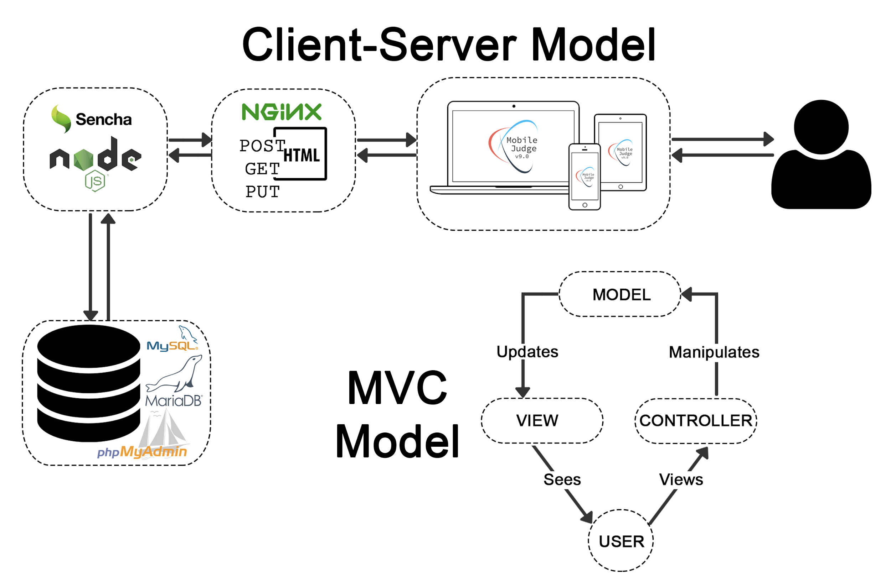

## System and Subsystem Decomposition

* **Views** - Contains all the views of the system and the content for the pages is rendered by Sencha. Different GUI elements on the pages trigger events.
* **Controllers** - Contains all the controllers of the system and represent the classes connecting the model and the view, and used to communicate between them.
* **Models** - Contains all the models of the system and represent the structure of the data and the methods to interact with the data store.

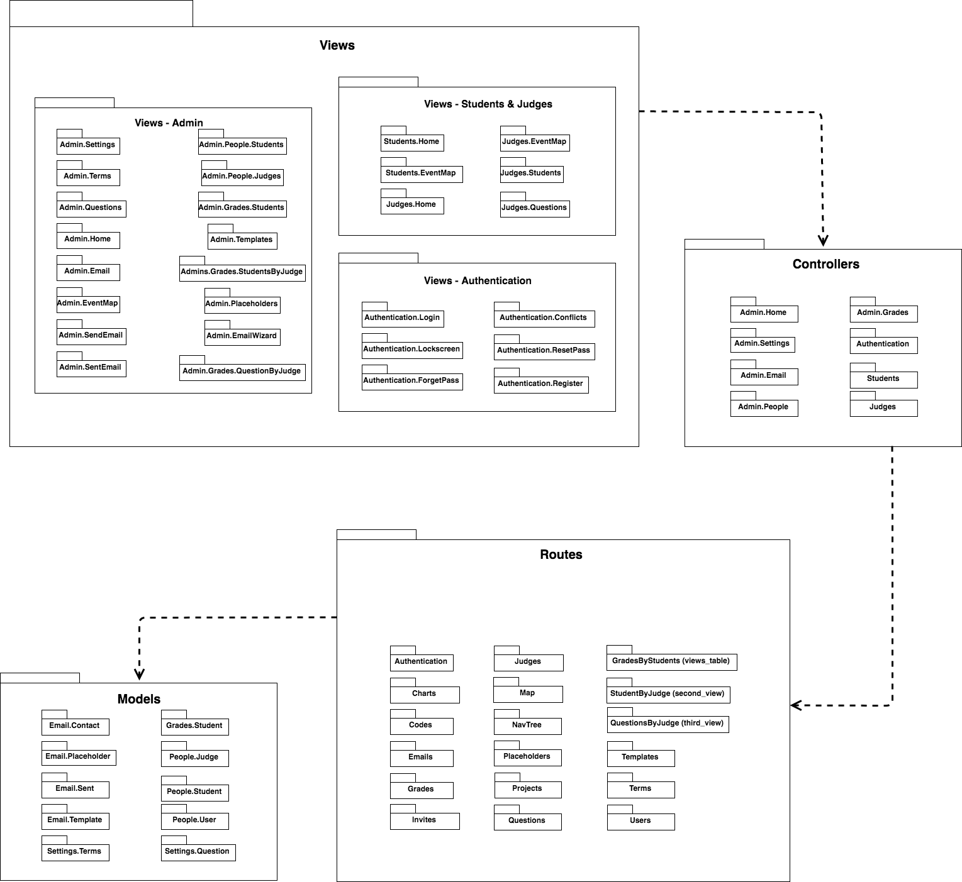

## Deployment Diagram

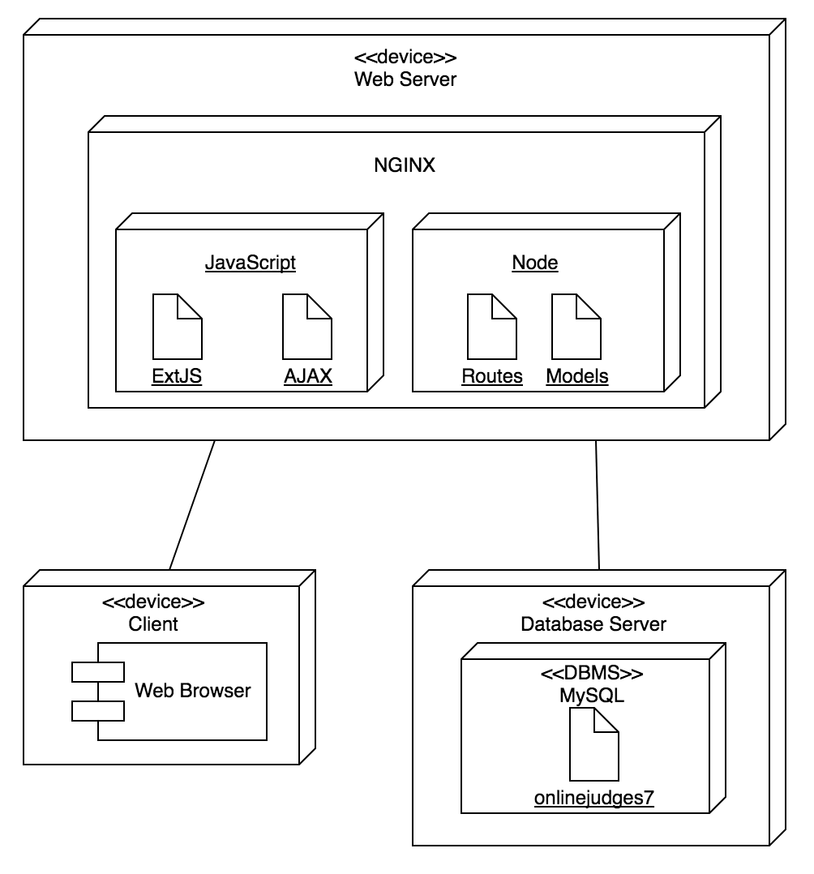

## Design Patterns

In Mobile Judge 9.0, there was no recognizable design patterns to create a reusable solution.

# System Validation

#647 - Allow student fields to be edited

|  |
| --- |
| **Test case ID:** MJ-647-01  **Description/Summary of Test:** Modifying Student’s Name Only  **Precondition:**   * Admin is currently logged into Mobile Judge account * Currently on the people side tab * Viewing the students gridview * Editing a student’s name   **Expected Results:** Student’s name only gets modified and updated.  **Actual Result:** Student’s name only got modified and updated.  **Status (Fail/Pass):** Pass |

|  |
| --- |
| **Test case ID:** MJ-647-02  **Description/Summary of Test:** Modifying Student’s Email Only  **Precondition:**   * Admin is currently logged into Mobile Judge account * Currently on the people side tab * Viewing the students gridview * Editing a student’s email   **Expected Results:** Student’s Email only gets modified and updated.  **Actual Result:** Student’s Email only got modified and updated.  **Status (Fail/Pass):** Pass |

|  |
| --- |
| **Test case ID:** MJ-647-03  **Description/Summary of Test:** Modifying Student’s Project Only  **Precondition:**   * Admin is currently logged into Mobile Judge account * Currently on the people side tab * Viewing the students gridview * Editing a student’s project   **Expected Results:** Student’s Project only gets modified and updated.  **Actual Result:** Student’s Project only got modified and updated.  **Status (Fail/Pass):** Pass |

|  |
| --- |
| **Test case ID:** MJ-647-04  **Description/Summary of Test:** Modifying Student’s Location Only  **Precondition:**   * Admin is currently logged into Mobile Judge account * Currently on the people side tab * Viewing the students gridview * Editing a student’s location   **Expected Results:** Student’s Location only gets modified and updated.  **Actual Result:** Student’s Location only got modified and updated.  **Status (Fail/Pass):** Pass |

|  |
| --- |
| **Test case ID:** MJ-647-05  **Description/Summary of Test:** Modifying Student’s State Only  **Precondition:**   * Admin is currently logged into Mobile Judge account * Currently on the people side tab * Viewing the students gridview * Editing a student’s state   **Expected Results:** Student’s State only gets modified and updated.  **Actual Result:** Student’s State only got modified and updated.  **Status (Fail/Pass):** Pass |

|  |
| --- |
| **Test case ID:** MJ-647-06  **Description/Summary of Test:** Modifying Multiple Student’s Fields  **Precondition:**   * Admin is currently logged into Mobile Judge account * Currently on the people side tab * Viewing the students gridview * Editing a student’s information   **Expected Results:** All selected fields get modified and updated.  **Actual Result:** All selected fields got modified and updated.  **Status (Fail/Pass):** Pass |

|  |
| --- |
| **Test case ID:** MJ-647-07  **Description/Summary of Test:** Modifying All Student’s Fields  **Precondition:**   * Admin is currently logged into Mobile Judge account * Currently on the people side tab * Viewing the students gridview * Editing a student’s information   **Expected Results:** All selected fields get modified and updated.  **Actual Result:** All selected fields got modified and updated.  **Status (Fail/Pass):** Pass |

|  |
| --- |
| **Test case ID:** MJ-647-08  **Description/Summary of Test:** Cancel modification of Student’s record  **Precondition:**   * Admin is currently logged into Mobile Judge account * Currently on the people side tab * Viewing the students gridview * Editing a student’s information, but cancels   **Expected Results:** Modified fields get reverted back to original information.  **Actual Result:** Modified fields got reverted back to original information.  **Status (Fail/Pass):** Pass |

|  |
| --- |
| **Test case ID:** MJ-647-09  **Description/Summary of Test:** Inputting invalid Email in Student Email Field  **Precondition:**   * Admin is currently logged into Mobile Judge account * Currently on the people side tab * Viewing the students gridview * Editing a student’s email   **Expected Results:** Admin gets message saying “This field should be an email address in the format “[user@example.com](mailto:user@example.com)” and does not allow the record to be updated.  **Actual Result:** Admin got message saying “This field should be an email address in the format “[user@example.com](mailto:user@example.com)” and does not allow the record to be updated.  **Status (Fail/Pass):** Pass |

**#648 - All judge fields to be edited**

|  |
| --- |
| **Test case ID:** MJ-648-01  **Description/Summary of Test:** Modifying Judge’s Name Only  **Precondition:**   * Admin is currently logged into Mobile Judge account * Currently on the people side tab * Viewing the judges gridview * Editing a judge’s name   **Expected Results:** Judge’s name only gets modified and updated.  **Actual Result:** Judge’s name only got modified and updated.  **Status (Fail/Pass):** Pass |

|  |
| --- |
| **Test case ID:** MJ-648-02  **Description/Summary of Test:** Modifying Judge’s Email Only  **Precondition:**   * Admin is currently logged into Mobile Judge account * Currently on the people side tab * Viewing the judges gridview * Editing a judge’s email   **Expected Results:** Judge’s Email only gets modified and updated.  **Actual Result:** Judge’s Email only got modified and updated.  **Status (Fail/Pass):** Pass |

|  |
| --- |
| **Test case ID:** MJ-648-03  **Description/Summary of Test:** Modifying Judge’s Title Only  **Precondition:**   * Admin is currently logged into Mobile Judge account * Currently on the people side tab * Viewing the judges gridview * Editing a judge’s title   **Expected Results:** Judge’s Project only gets modified and updated.  **Actual Result:** Judge’s Project only got modified and updated.  **Status (Fail/Pass):** Pass |

|  |
| --- |
| **Test case ID:** MJ-648-04  **Description/Summary of Test:** Modifying Judge’s Organization Only  **Precondition:**   * Admin is currently logged into Mobile Judge account * Currently on the people side tab * Viewing the judges gridview * Editing a judge’s organization   **Expected Results:** Judge’s Location only gets modified and updated.  **Actual Result:** Judge’s Location only got modified and updated.  **Status (Fail/Pass):** Pass |

|  |
| --- |
| **Test case ID:** MJ-648-05  **Description/Summary of Test:** Modifying Judge’s State Only  **Precondition:**   * Admin is currently logged into Mobile Judge account * Currently on the people side tab * Viewing the judges gridview * Editing a judge’s state   **Expected Results:** Judge’s State only gets modified and updated.  **Actual Result:** Judge’s State only got modified and updated.  **Status (Fail/Pass):** Pass |

|  |
| --- |
| **Test case ID:** MJ-648-06  **Description/Summary of Test:** Modifying Multiple Judge’s Fields  **Precondition:**   * Admin is currently logged into Mobile Judge account * Currently on the people side tab * Viewing the judges gridview * Editing a judge’s information   **Expected Results:** All selected fields get modified and updated.  **Actual Result:** All selected fields got modified and updated.  **Status (Fail/Pass):** Pass |

|  |
| --- |
| **Test case ID:** MJ-648-07  **Description/Summary of Test:** Cancel modification of Judge’s record  **Precondition:**   * Admin is currently logged into Mobile Judge account * Currently on the people side tab * Viewing the judges gridview * Editing a judge’s information, but cancels   **Expected Results:** Modified fields get reverted back to original information.  **Actual Result:** Modified fields got reverted back to original information.  **Status (Fail/Pass):** Pass |

|  |
| --- |
| **Test case ID:** MJ-648-08  **Description/Summary of Test:** Inputting invalid Email in Judge’s Email Field  **Precondition:**   * Admin is currently logged into Mobile Judge account * Currently on the people side tab * Viewing the judges gridview * Editing a judge’s email   **Expected Results:** Admin gets message saying “This field should be an email address in the format “[user@example.com](mailto:user@example.com)” and does not allow the record to be updated.  **Actual Result:** Admin got message saying “This field should be an email address in the format “[user@example.com](mailto:user@example.com)” and does not allow the record to be updated.  **Status (Fail/Pass):** Pass |

#649 - Download/Export Student Report

|  |
| --- |
| **Test case ID:** MJ-649-01  **Description/Summary of Test:** Download Student’s Grades for Active Semester  **Precondition:**   * Admin is currently logged into Mobile Judge account * Currently on the people side tab * Viewing the students gridview   **Expected Results:** Popup requesting Admin to save or open CSV file of all the student’s grade who are active.  **Actual Result:** A popup displayed once Download Grades was clicked, and the file contained only the active semester’s grades.  **Status (Fail/Pass):** Pass |

#650 - Bug: Fix issue with sync

|  |
| --- |
| **Test case ID:** MJ-650-01  **Description/Summary of Test:** Sync and update all students record for current term  **Precondition:**   * Admin is currently logged into Mobile Judge account * Currently on the people side tab * Viewing the students gridview * Clicks on the Sync button   **Expected Results:** Student’s records get updated except for the location field which stays the same.  **Actual Result:** All the student’s records got updated except for the location field which stayed the same.  **Status (Fail/Pass):** Pass |

|  |
| --- |
| **Test case ID:** MJ-650-02  **Description/Summary of Test:** Sync and cancel the update of all students record for current term  **Precondition:**   * Admin is currently logged into Mobile Judge account * Currently on the people side tab * Viewing the students gridview * Clicks on the Sync button, but cancels   **Expected Results:** Student’s records does not get updated  **Actual Result:** Student’s records did not get updated  **Status (Fail/Pass):** Pass |

#651 - Add new filter button to Students

|  |
| --- |
| **Test case ID:** MJ-651-01  **Description/Summary of Test:** Select all the filter buttons in the Students Tab  **Precondition:**   * Admin is currently logged into Mobile Judge account * Currently on the people side tab * Viewing the students gridview * Checks the filter checkbox   **Expected Results:** When checkbox checked, all the filter buttons should become blue and selected, the view then shows the updated filter that has been applied.  **Actual Result:**When checkbox checked, all the filter buttons became blue and selected, the view then showed the updated filter that was applied.  **Status (Fail/Pass):** Pass |

|  |
| --- |
| **Test case ID:** MJ-651-02  **Description/Summary of Test:** Unselect all the filter buttons in the Students Tab  **Precondition:**   * Admin is currently logged into Mobile Judge account * Currently on the people side tab * Viewing the students gridview * Unchecks the filter checkbox   **Expected Results:** When checkbox unchecked, all the filter buttons should become white and selected, the view then shows the updated filter that has been applied.  **Actual Result:**When checkbox unchecked, all the filter buttons became white and selected, the view then showed the updated filter that was applied.  **Status (Fail/Pass):** Pass |

#652 - Add new filter button to Judges

|  |
| --- |
| **Test case ID:** MJ-652-01  **Description/Summary of Test:** Select all the filter buttons in the Judges Tab  **Precondition:**   * Admin is currently logged into Mobile Judge account * Currently on the people side tab * Viewing the judges gridview * Checks the filter checkbox   **Expected Results:** When checkbox checked, all the filter buttons should become blue and selected, the view then shows the updated filter that has been applied.  **Actual Result:**When checkbox checked, all the filter buttons became blue and selected, the view then showed the updated filter that was applied.  **Status (Fail/Pass):** Pass |

|  |
| --- |
| **Test case ID:** MJ-652-02  **Description/Summary of Test:** Unselect all the filter buttons in the Judges Tab  **Precondition:**   * Admin is currently logged into Mobile Judge account * Currently on the people side tab * Viewing the judges gridview * Unchecks the filter checkbox   **Expected Results:** When checkbox unchecked, all the filter buttons should become white and selected, the view then shows the updated filter that has been applied.  **Actual Result:**When checkbox unchecked, all the filter buttons became white and selected, the view then showed the updated filter that was applied.  **Status (Fail/Pass):** Pass |

#653 - Add downloadable template for Judges

|  |
| --- |
| **Test case ID:** MJ-653-01  **Description/Summary of Test:** Download Judge’s Import Template  **Precondition:**   * Admin is currently logged into Mobile Judge account * Currently on the people side tab * Viewing the judges gridview * Click Download Template   **Expected Results:** Popup requesting Admin to save or open CSV file of a Judge Import Template.  **Actual Result:** A popup displayed once Download Template was clicked, and the file contained a template to fill out and be used when importing judges to Mobile Judge.  **Status (Fail/Pass):** Pass |

#654 - Modify import function

|  |
| --- |
| **Test case ID:** MJ-649-01  **Description/Summary of Test:** Import Judges to Mobile Judge  **Precondition:**   * Admin is currently logged into Mobile Judge account * Currently on the people side tab * Viewing the judges gridview * Click import judge and selects file   **Expected Results:** A popup appears with the updates that will be applied, and the Judges are added to Mobile Judge.  **Actual Result:** A popup appeared with the update that were applied and the view updated with the new Judges.  **Status (Fail/Pass):** Pass |

|  |
| --- |
| **Test case ID:** MJ-649-01  **Description/Summary of Test:** Import Judges to Mobile Judge using incorrect Template  **Precondition:**   * Admin is currently logged into Mobile Judge account * Currently on the people side tab * Viewing the judges gridview * Click import judge and selects incorrect file   **Expected Results:** Admin clicks import and selects an invalid CSV file. A popup appears with the updates that will be applied, and no judges get added.  **Actual Result:** A popup appeared with the updates that were applied, and there were no updates applied.  **Status (Fail/Pass):** Pass |

#655 - Add Grades tab

|  |
| --- |
| **Test case ID:** MJ-650-01  **Description/Summary of Test:** View student’s grades  **Precondition:**   * Admin is currently logged into Mobile Judge account * Currently on the grades side tab * Viewing the students gridview   **Expected Results:** A list of all students in active term should be shown with their grade.  **Actual Result:** There was a list of students for the active term and their grades  **Status (Fail/Pass):** Pass |

|  |
| --- |
| **Test case ID:** MJ-655-02  **Description/Summary of Test:** View Judges who graded the student  **Precondition:**   * Admin is currently logged into Mobile Judge account * Currently on the grades side tab * Viewing the students gridview * Clicks eyeball icon on student record   **Expected Results:** A list of all judges who graded that student should appear with the grade given.  **Actual Result:** A popup appears with proper information  **Status (Fail/Pass):** Pass |

|  |
| --- |
| **Test case ID:** MJ-655-03  **Description/Summary of Test:** View Judges who graded the student and their particular grade per question  **Precondition:**   * Admin is currently logged into Mobile Judge account * Currently on the grades side tab * Viewing the students gridview * Clicks eyeball icon on student record * Clicks eyeball icon on judge record   **Expected Results:** A list of questions and the grades given by that judge for that student should appear.  **Actual Result:** A popup appears with proper information  **Status (Fail/Pass):** Pass |

#656 - Add approve and reject buttons

|  |
| --- |
| **Test case ID:** MJ-656-01  **Description/Summary of Test:** Change a single student’s grade to accepted  **Precondition:**   * Admin is currently logged into Mobile Judge account * Currently on the grades side tab * Viewing the students gridview * Clicks traffic light to make it green on a student record   **Expected Results:** Student’s accepted grade gets calculated correctly from judge’s grades  **Actual Result:** Student’s accepted grade got calculated correctly from judge’s grades  **Status (Fail/Pass):** Pass |

|  |
| --- |
| **Test case ID:** MJ-656-02  **Description/Summary of Test:** Change a single student’s grade to pending  **Precondition:**   * Admin is currently logged into Mobile Judge account * Currently on the grades side tab * Viewing the students gridview * Clicks traffic light to make it yellow on a student record   **Expected Results:** Student’s accepted grade become zero  **Actual Result:** Student’s accepted grade became zero  **Status (Fail/Pass):** Pass |

|  |
| --- |
| **Test case ID:** MJ-656-03  **Description/Summary of Test:** Change a single student’s grade to rejected  **Precondition:**   * Admin is currently logged into Mobile Judge account * Currently on the grades side tab * Viewing the students gridview * Clicks traffic light to make it red on a student record   **Expected Results:** Student’s accepted grade become zero  **Actual Result:** Student’s accepted grade became zero  **Status (Fail/Pass):** Pass |

|  |
| --- |
| **Test case ID:** MJ-656-04  **Description/Summary of Test:** Change all student’s grade to accepted  **Precondition:**   * Admin is currently logged into Mobile Judge account * Currently on the grades side tab * Viewing the students gridview * Clicks global traffic light and selects accept-all   **Expected Results:** Every student’s grade gets correctly calculated from judge’s grades  **Actual Result:** Every student’s grade got correctly calculated from judge’s grades  **Status (Fail/Pass):** Pass |

|  |
| --- |
| **Test case ID:** MJ-656-05  **Description/Summary of Test:** Change all student’s grade to pending  **Precondition:**   * Admin is currently logged into Mobile Judge account * Currently on the grades side tab * Viewing the students gridview * Clicks global traffic light and selects pend-all   **Expected Results:** Student’s accepted grade become zero  **Actual Result:** Student’s accepted grade became zero  **Status (Fail/Pass):** Pass |

|  |
| --- |
| **Test case ID:** MJ-656-06  **Description/Summary of Test:** Change all student’s grade to rejected  **Precondition:**   * Admin is currently logged into Mobile Judge account * Currently on the grades side tab * Viewing the students gridview * Clicks global traffic light and selects reject-all   **Expected Results:** Every student’s accepted grade becomes zero  **Actual Result:** Every student’s accepted grade became zero  **Status (Fail/Pass):** Pass |

|  |
| --- |
| **Test case ID:** MJ-656-07  **Description/Summary of Test:** Cancel mass student grade status change  **Precondition:**   * Admin is currently logged into Mobile Judge account * Currently on the grades side tab * Viewing the students gridview * Clicks global traffic light and selects cancel   **Expected Results:** No change occurs to any student’s grade status  **Actual Result:** No change occurred to any student’s grade status  **Status (Fail/Pass):** Pass |

#658 - Add combobox for projects in Students

|  |
| --- |
| **Test case ID:** MJ-658-01  **Description/Summary of Test:** Change a student’s project  **Precondition:**   * Admin is currently logged into Mobile Judge account * Currently on the people side tab * Viewing the students gridview * Clicks student record and selects project from combobox   **Expected Results:** A list of the current projects should appear and if the modification is approved, the student’s project should change and update.  **Actual Result:** A list of the current projects appeared, and once the project was selected and updated, the student’s project successfully changed and updated.  **Status (Fail/Pass):** Pass |

|  |
| --- |
| **Test case ID:** MJ-658-02  **Description/Summary of Test:** Cancel changing a student’s project  **Precondition:**   * Admin is currently logged into Mobile Judge account * Currently on the people side tab * Viewing the students gridview * Clicks student record and selects project from combobox, but cancels   **Expected Results:** A list of the current projects should appear and if the modification is canceled, the student’s project should not change.  **Actual Result:** A list of the current projects appeared, and once the project was selected and canceled, the student’s project successfully did not change.  **Status (Fail/Pass):** Pass |

#659 - Bug: Fix issue with Location edit

|  |
| --- |
| **Test case ID:** MJ-659-01  **Description/Summary of Test:** Change a student’s location information  **Precondition:**   * Admin is currently logged into Mobile Judge account * Currently on the people side tab * Viewing the students gridview * Clicks student record and puts 0 in location field   **Expected Results:** If a zero is typed into the field, N/A should be shown as the location.  **Actual Result:** N/A appeared as the result.  **Status (Fail/Pass):** Pass |

|  |
| --- |
| **Test case ID:** MJ-659-02  **Description/Summary of Test:** Change a student’s location information  **Precondition:**   * Admin is currently logged into Mobile Judge account * Currently on the people side tab * Viewing the students gridview * Clicks student record and puts any number from 1-254 in location field   **Expected Results:** If a number from 1-254 is typed into the field, the word “Location” and that number should be shown as student’s location.  **Actual Result:** All the numbers from 1-254 were type and the correct output was displayed and saved for the student  **Status (Fail/Pass):** Pass |

|  |
| --- |
| **Test case ID:** MJ-659-02  **Description/Summary of Test:** Change a student’s location information  **Precondition:**   * Admin is currently logged into Mobile Judge account * Currently on the people side tab * Viewing the students gridview * Clicks student record and puts a number not between 0-254 in location field   **Expected Results:** If a number from not from 0-254 is typed into the field, popup will appear saying input valid location number  **Actual Result:** A popup appeared saying input valid location number  **Status:** Pass |

#661 - Modify Judge’s Registration form descriptions

|  |
| --- |
| **Test case ID:** MJ-661-01  **Description/Summary of Test:** Prospective judge registers  **Precondition:**   * Received judge invitation * Accept to attend * Redirect to registration and create account   **Expected Results:** All the fields in the registration form should be saved as a field in the database.  **Actual Result:** Each field was successfully saved in the database including salutation  **Status (Fail/Pass):** Pass |

|  |
| --- |
| **Test case ID:** MJ-661-02  **Description/Summary of Test:** Prospective judge registers  **Precondition:**   * Received judge invitation * Accept to attend * Redirect to registration and create account   **Expected Results:** Examples of what should be in each field should be shown.  **Actual Result:** Each field had an example of what was required for the field  **Status (Fail/Pass):** Pass |

|  |
| --- |
| **Test case ID:** MJ-661-03  **Description/Summary of Test:** Prospective judge registers  **Precondition:**   * Received judge invitation * Accept to attend * Redirect to registration and create account   **Expected Results:** Description of how to select conflicts of interest should give a judge the correct idea on who to select in this phase.  **Actual Result:** The description was clear and concise allowing the phase to be easy to understand.  **Status (Fail/Pass):** Pass |

|  |
| --- |
| **Test case ID:** MJ-661-04  **Description/Summary of Test:** Prospective judge registers  **Precondition:**   * Received judge invitation * Accept to attend * Redirect to registration and create account   **Expected Results:** Once registration is complete the judge’s account should be created.  **Actual Result:** The account is created once the registration is complete.  **Status (Fail/Pass):** Pass |

#662 - Add visual cue for filter buttons

|  |
| --- |
| **Test case ID**: MJ-662-01  **Description/Summary of Test**: Visual checkbox cue while filtering  **Precondition**:   * Admin is currently logged into Mobile Judge account * Currently on the people side tab * Viewing the students gridview * Select only some of the filters   **Expected Results:** If some filter buttons are selected, a minus symbol should appear in the checkbox.  **Actual Result:** When some filter buttons were selected, a minus symbol was in the checkbox  **Status (Fail/Pass):** Pass |

|  |
| --- |
| **Test case ID**: MJ-662-02  **Description/Summary of Test**: Visual checkbox cue while filtering  **Precondition**:   * Admin is currently logged into Mobile Judge account * Currently on the people side tab * Viewing the students gridview * Select all of the filters   **Expected Results:** If all filter buttons are selected, a check symbol should appear in the checkbox.  **Actual Result:** When all filter buttons were selected, a check symbol was in the checkbox  **Status (Fail/Pass):** Pass |

|  |
| --- |
| **Test case ID**: MJ-662-03  **Description/Summary of Test**: Visual checkbox cue while filtering  **Precondition**:   * Admin is currently logged into Mobile Judge account * Currently on the people side tab * Viewing the students gridview * Select none of the filters   **Expected Results:** If none of the filter buttons are selected, the checkbox should be empty.  **Actual Result:** When none of the filter buttons were selected, the checkbox was empty.  **Status (Fail/Pass):** Pass |

#663 - Add combobox in students/judges for state

|  |
| --- |
| **Test case ID**: MJ-663-01  **Description/Summary of Test**: Change students state  **Precondition**:   * Admin is currently logged into Mobile Judge account * Currently on the people side tab * Viewing the students gridview * Selects a student and changes their state   **Expected Results:** The student’s state changes and saves.  **Actual Result:** The student’s state changed and saved.  **Status (Fail/Pass):** Pass |

|  |
| --- |
| **Test case ID**: MJ-663-02  **Description/Summary of Test**: Change students state  **Precondition**:   * Admin is currently logged into Mobile Judge account * Currently on the people side tab * Viewing the judges gridview * Selects a judge and changes their state   **Expected Results:** The judge’s state changes and saves.  **Actual Result:** The judge’s state changed and saved.  **Status (Fail/Pass):** Pass |

#664 - Add Students view to Grades

|  |
| --- |
| **Test case ID**: MJ-664-01  **Description/Summary of Test**: View all student’s grade in active semester  **Precondition**:   * Admin is currently logged into Mobile Judge account * Currently on the grade side tab * Viewing the student gridview   **Expected Results:** Every active student in the semester is displayed with their grade  **Actual Result:** Every active student in the semester is displayed with their grade  **Status (Fail/Pass):** Pass |

#665 - Add a Judges view for each student

|  |
| --- |
| **Test case ID**: MJ-665-01  **Description/Summary of Test**: View judges who graded a student  **Precondition**:   * Admin is currently logged into Mobile Judge account * Currently on the grade side tab * Viewing the student gridview * Select a student   **Expected Results:** Popup appears with list of judges who graded the selected student  **Actual Result:** Popup appears with list of judges who graded the selected student  **Status (Fail/Pass):** Pass |

#666 - Add a Questions view for each judge

|  |
| --- |
| **Test case ID**: MJ-666-01  **Description/Summary of Test**: View question for each judge who graded a student  **Precondition**:   * Admin is currently logged into Mobile Judge account * Currently on the grade side tab * Viewing the student gridview * Select a student * Select a judge   **Expected Results:** Popup appears with list of questions that the judge scored for a student  **Actual Result:** Popup appears with list of questions that the judge scored for a student  **Status (Fail/Pass):** Pass |

#667 - Expand descriptions for Registration Form

|  |
| --- |
| **Test case ID:** MJ-667-01  **Description/Summary of Test:** Prospective judge registers  **Precondition:**   * Received judge invitation * Accept to attend * Redirect to registration and create account   **Expected Results:** Concise descriptions on each field while registering  **Actual Result:** Concise descriptions on each field while registering  **Status (Fail/Pass):** Pass |

#669 - Add filter buttons with checkbox to Grades

|  |
| --- |
| **Test case ID**: MJ-669-01  **Description/Summary of Test**: Filter all accepted grades  **Precondition**:   * Admin is currently logged into Mobile Judge account * Currently on the grade side tab * Viewing the student gridview * Selects accepted filter   **Expected Results:** Gridview updates and displays the appropriate records  **Actual Result:** Gridview updates and displays the appropriate records  **Status (Fail/Pass):** Pass |

|  |
| --- |
| **Test case ID**: MJ-669-02  **Description/Summary of Test**: Filter all pending grades  **Precondition**:   * Admin is currently logged into Mobile Judge account * Currently on the grade side tab * Viewing the student gridview * Selects pending filter   **Expected Results:** Gridview updates and displays the appropriate records  **Actual Result:** Gridview updates and displays the appropriate records  **Status (Fail/Pass):** Pass |

|  |
| --- |
| **Test case ID**: MJ-669-03  **Description/Summary of Test**: Filter all rejected grades  **Precondition**:   * Admin is currently logged into Mobile Judge account * Currently on the grade side tab * Viewing the student gridview * Selects rejected filter   **Expected Results:** Gridview updates and displays the appropriate records  **Actual Result:** Gridview updates and displays the appropriate records  **Status (Fail/Pass):** Pass |

|  |
| --- |
| **Test case ID**: MJ-669-04  **Description/Summary of Test**: Filter combinations of grade statuses  **Precondition**:   * Admin is currently logged into Mobile Judge account * Currently on the grade side tab * Viewing the student gridview * Selects any combination of filters   **Expected Results:** Gridview updates and displays the appropriate records  **Actual Result:** Gridview updates and displays the appropriate records  **Status (Fail/Pass):** Pass |

# Appendix

## Appendix A - UML Diagrams

**Use Case Diagram**

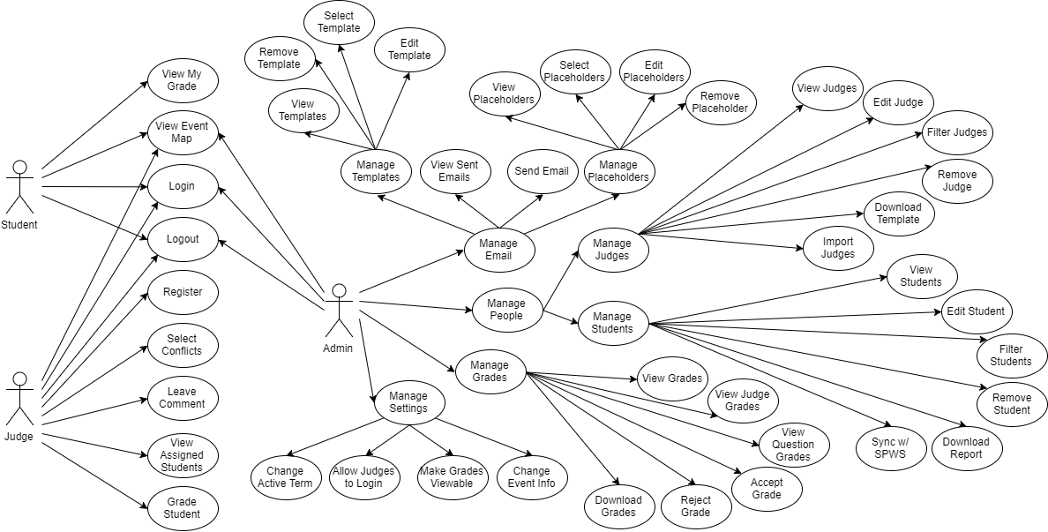

**Minimal Class Diagram**

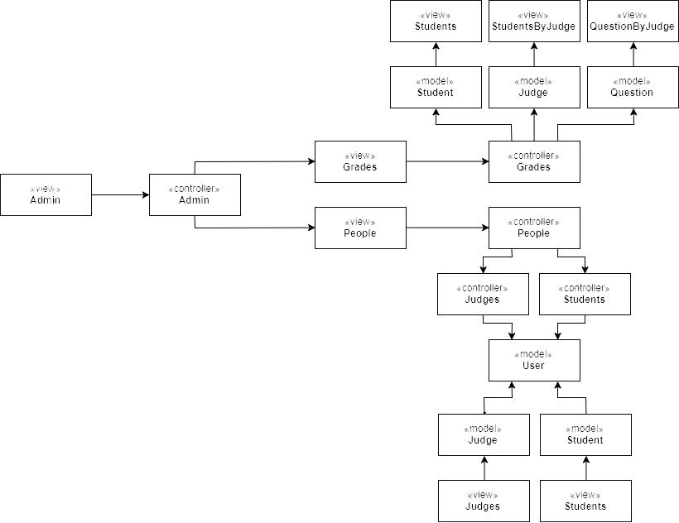

**UML Diagrams - Static & Dynamic Diagrams**

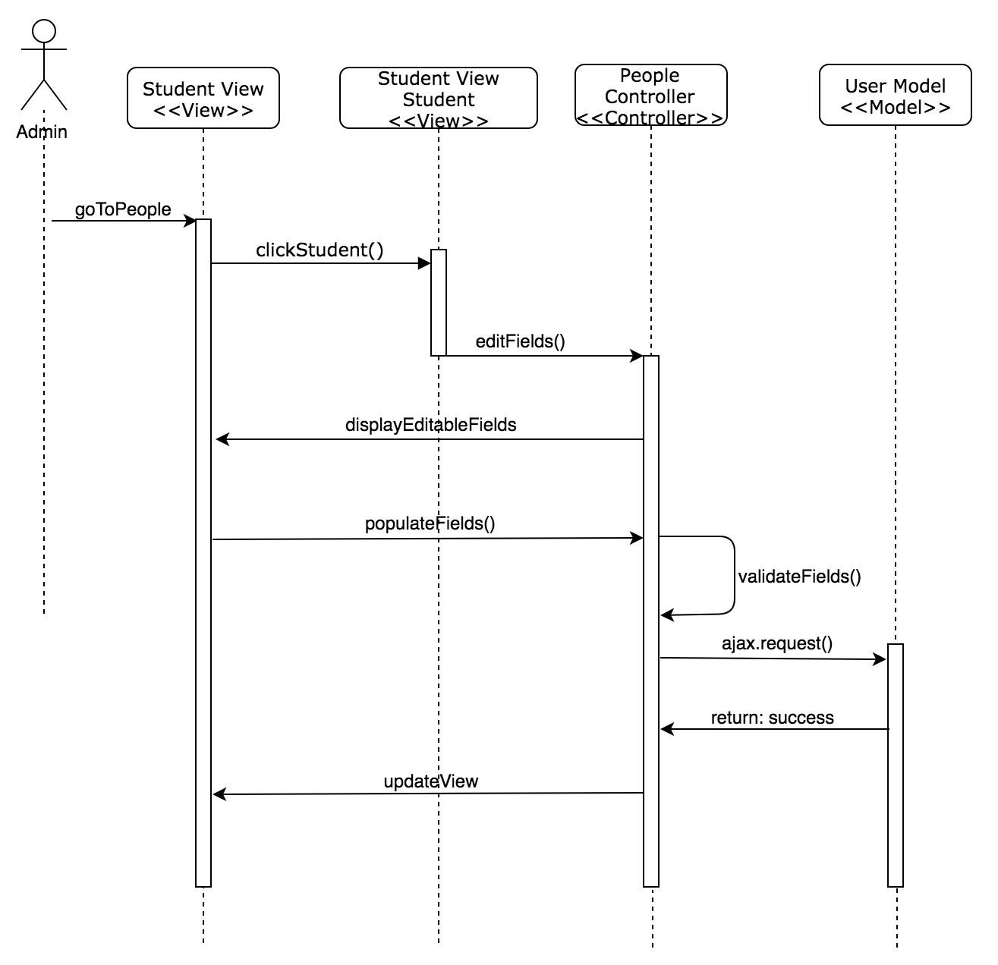

Student Information Field Editable Sequence Diagram

## 

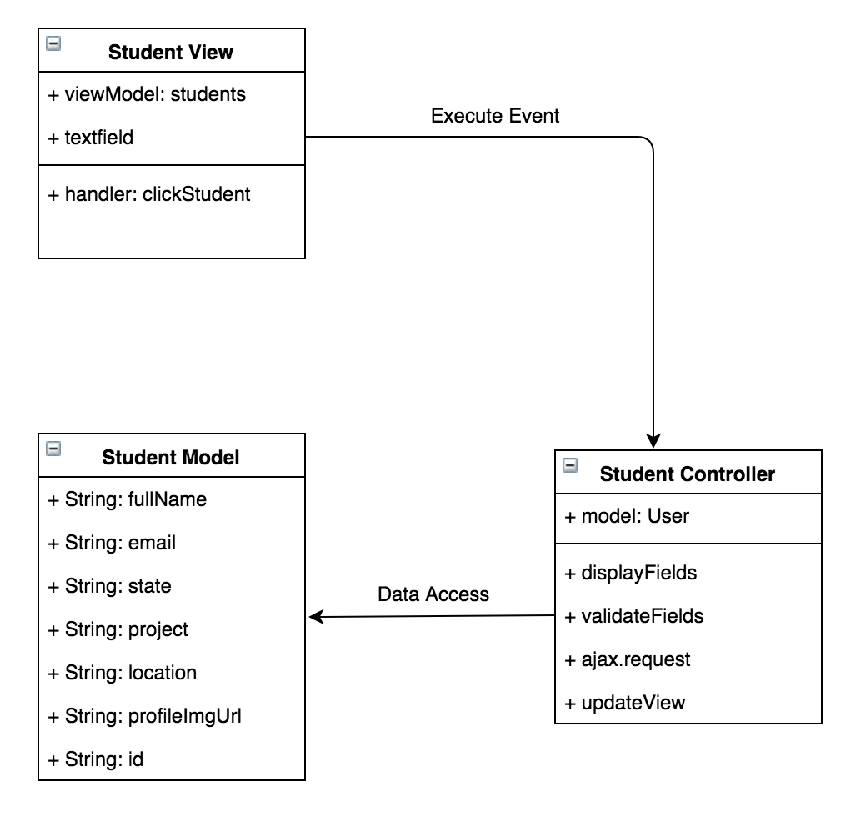

Student Information Field Editable Class Diagram

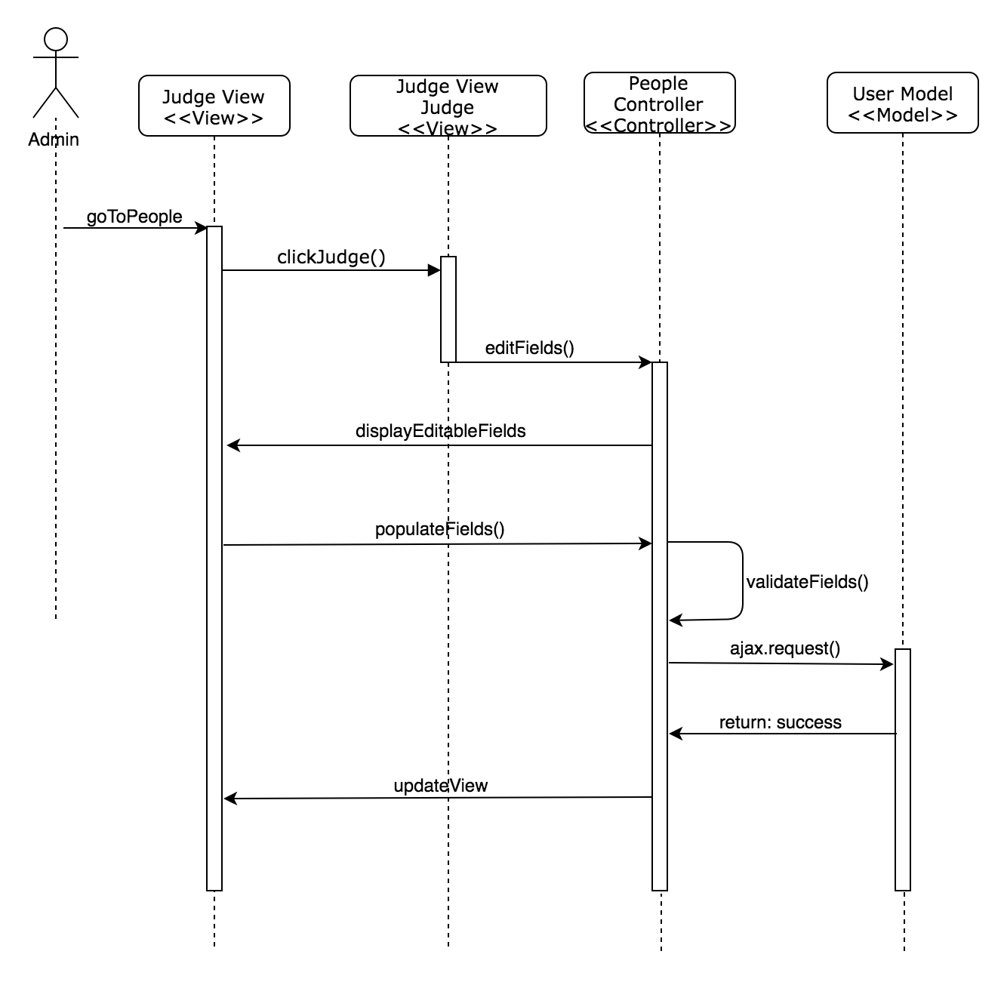

Judge Information Field Editable Sequence Diagram

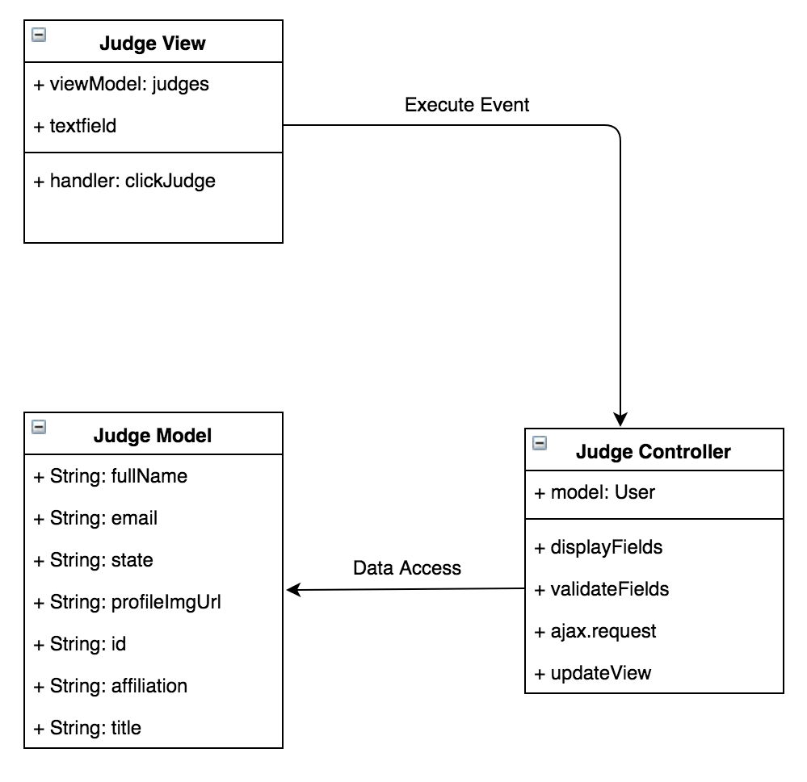

Judge Information Field Editable Class Diagram

## 

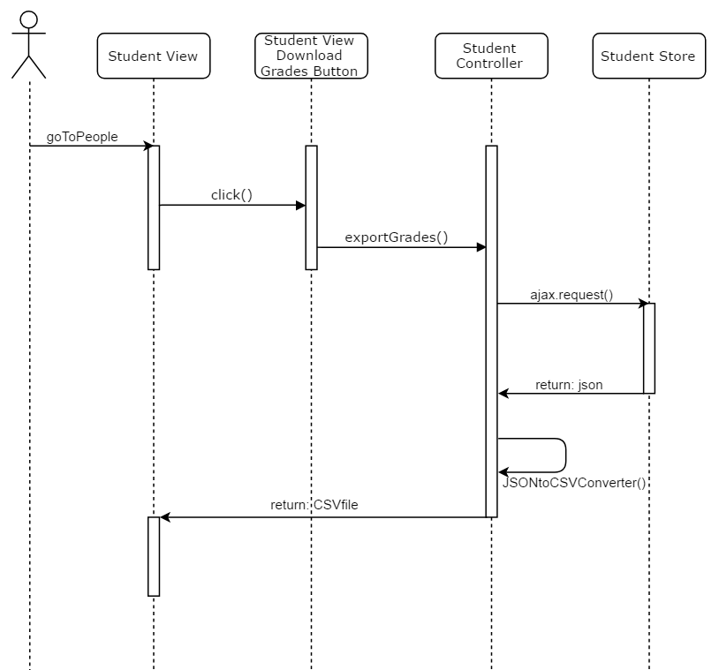

Student Download Report Sequence Diagram

## 

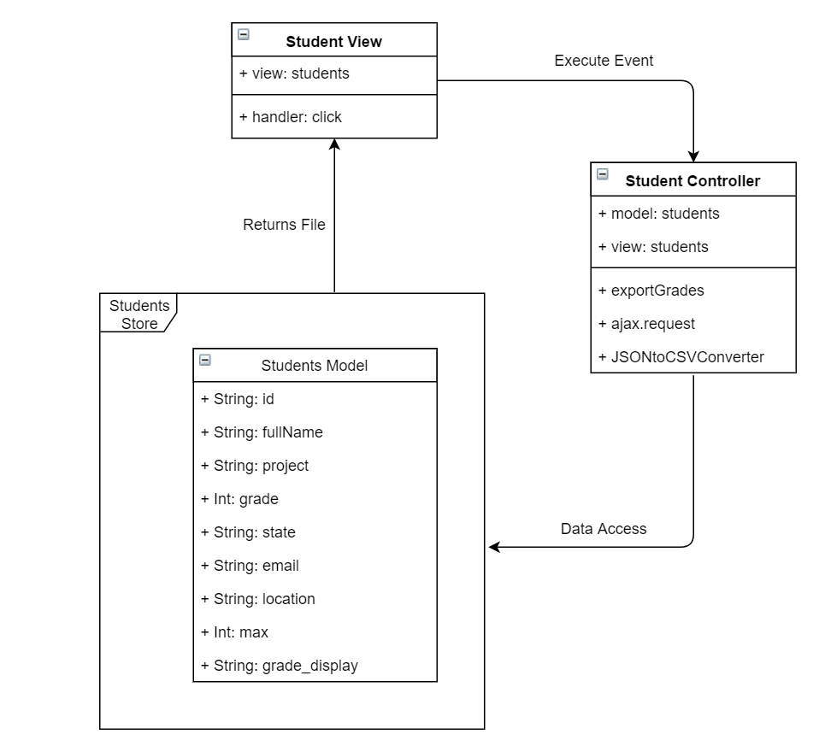

Student Download Report Class Diagram

## 

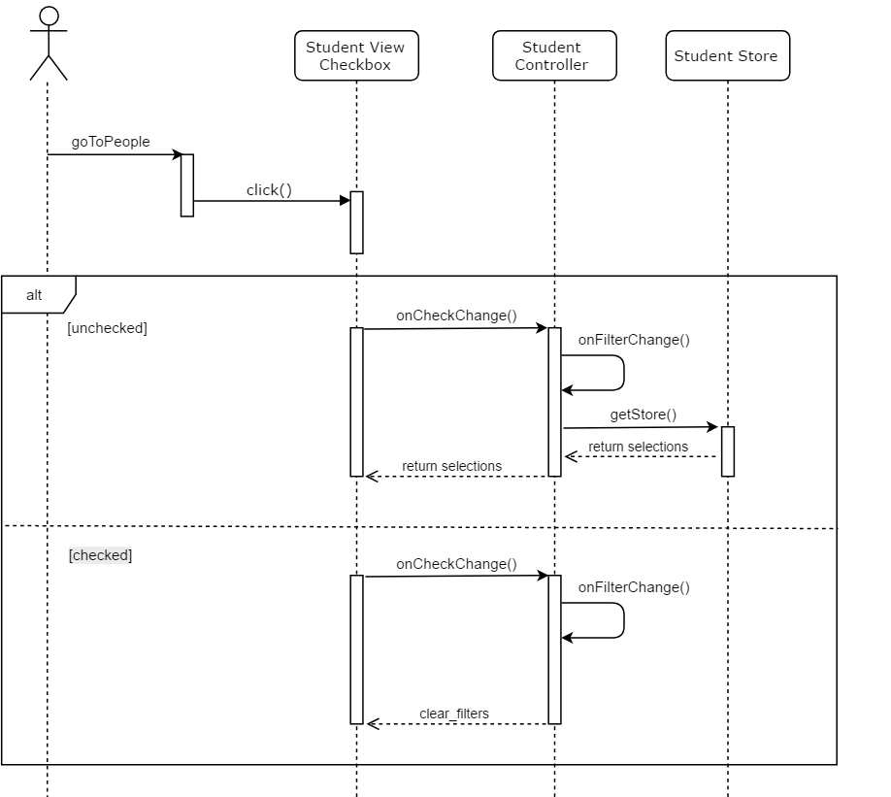

Student Filter CheckBox Sequence Diagram

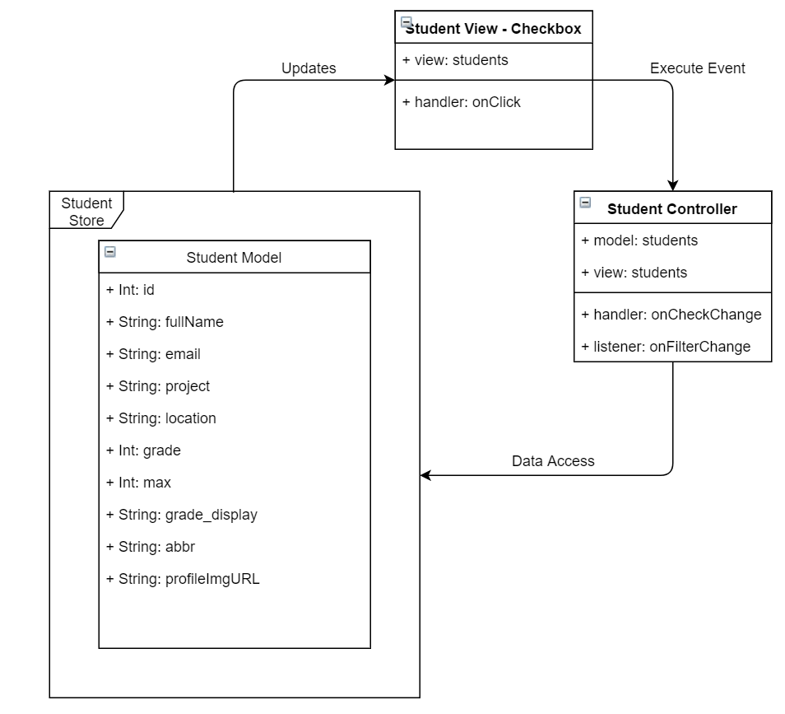

Student Filter CheckBox Class Diagram

## 

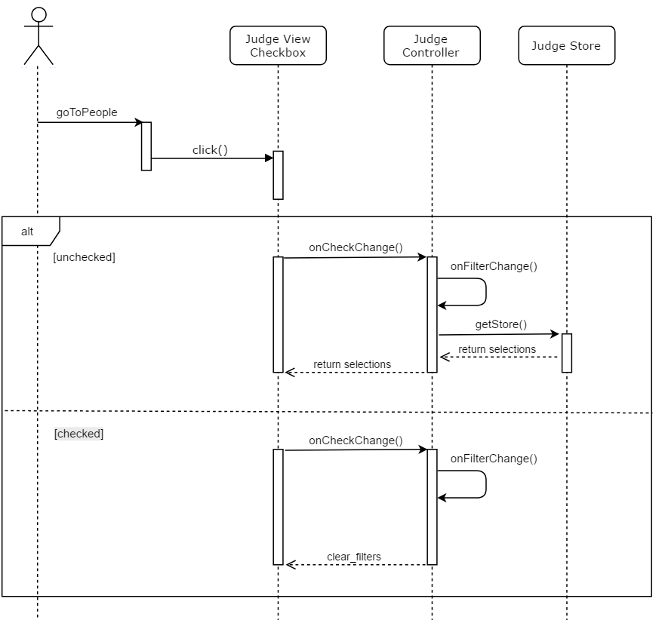

Judge Filter CheckBox Sequence Diagram

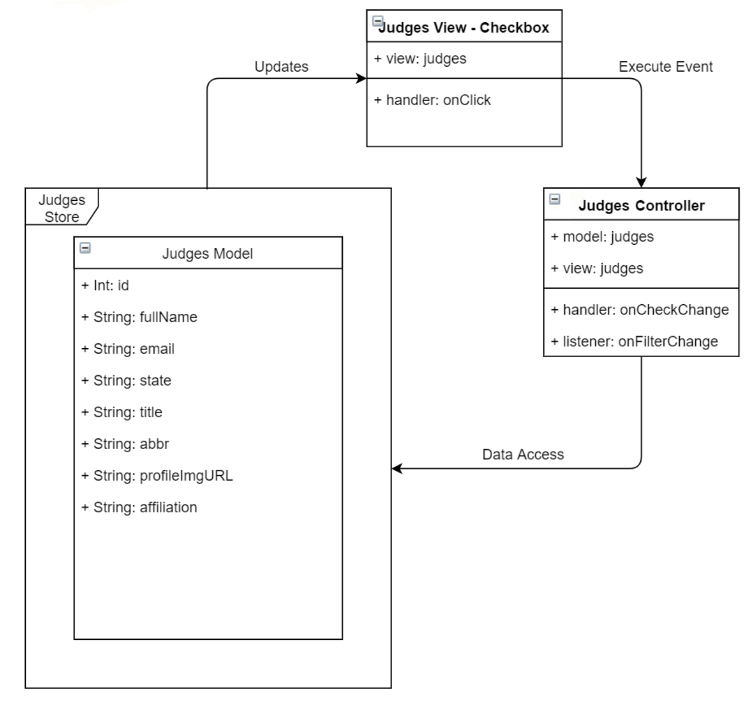

Judge Filter CheckBox Class Diagram

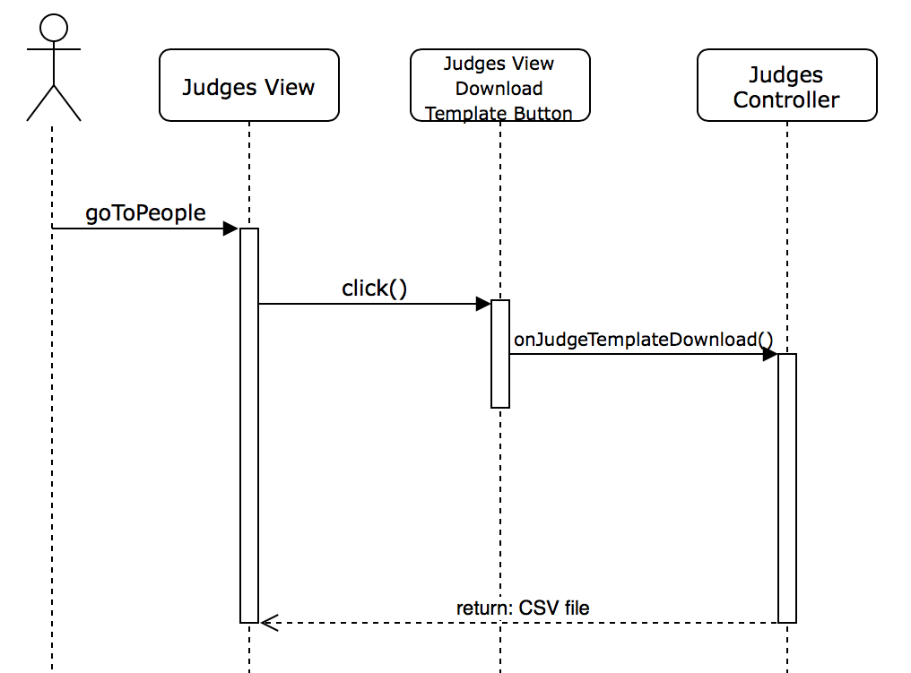

Judges CSV Template Download Sequence Diagram

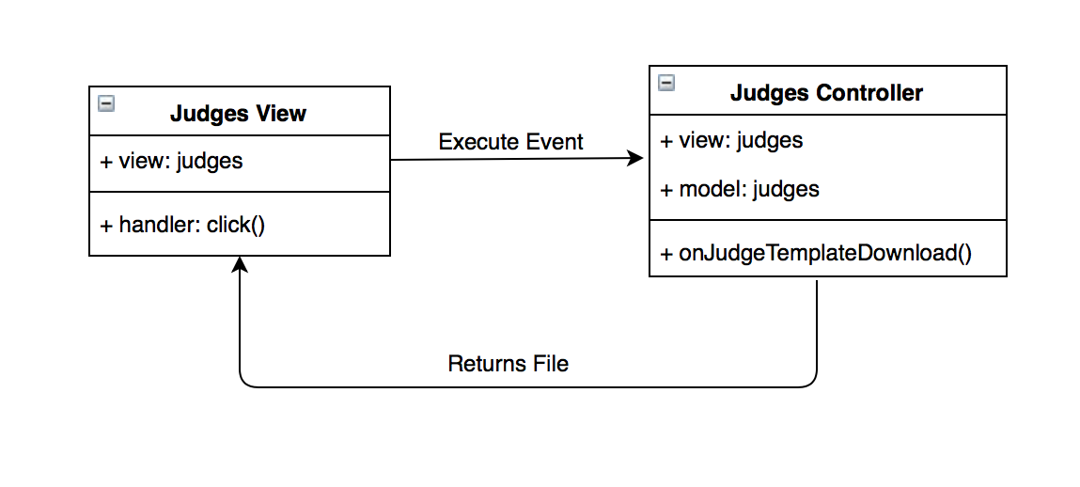

Judges CSV Template Download Class Diagram

## 

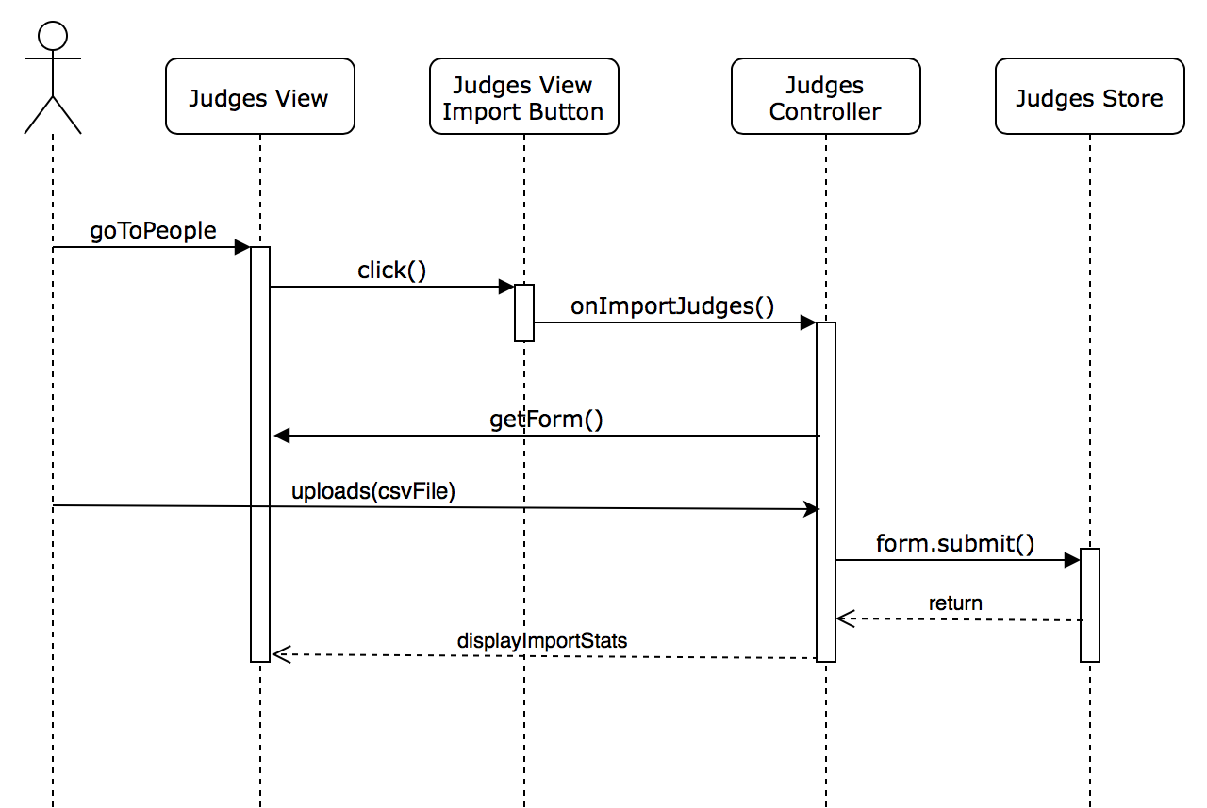

Judges Import CSV Template Sequence Diagram

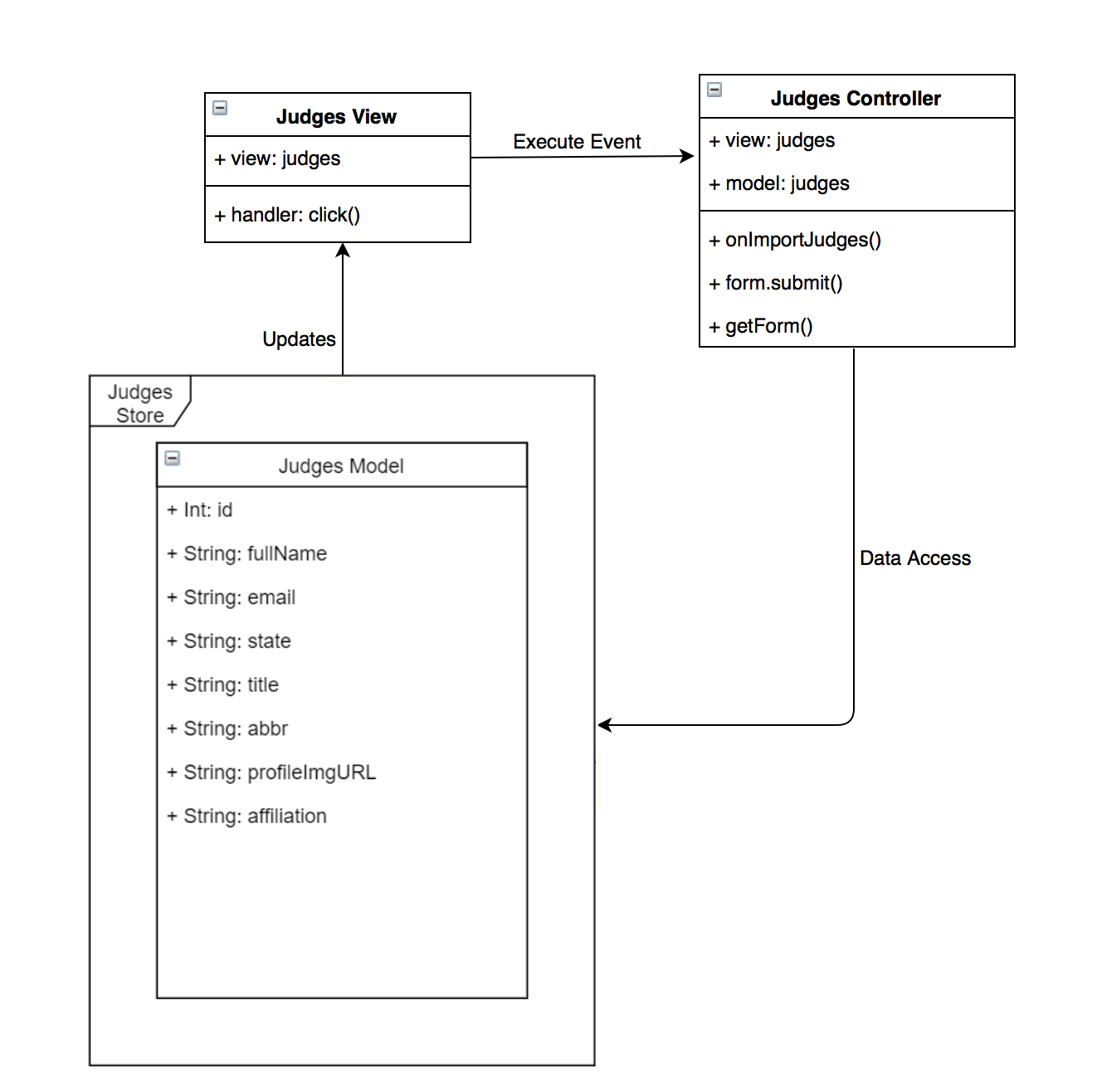

Judges Import CSV Template Class Diagram

## 

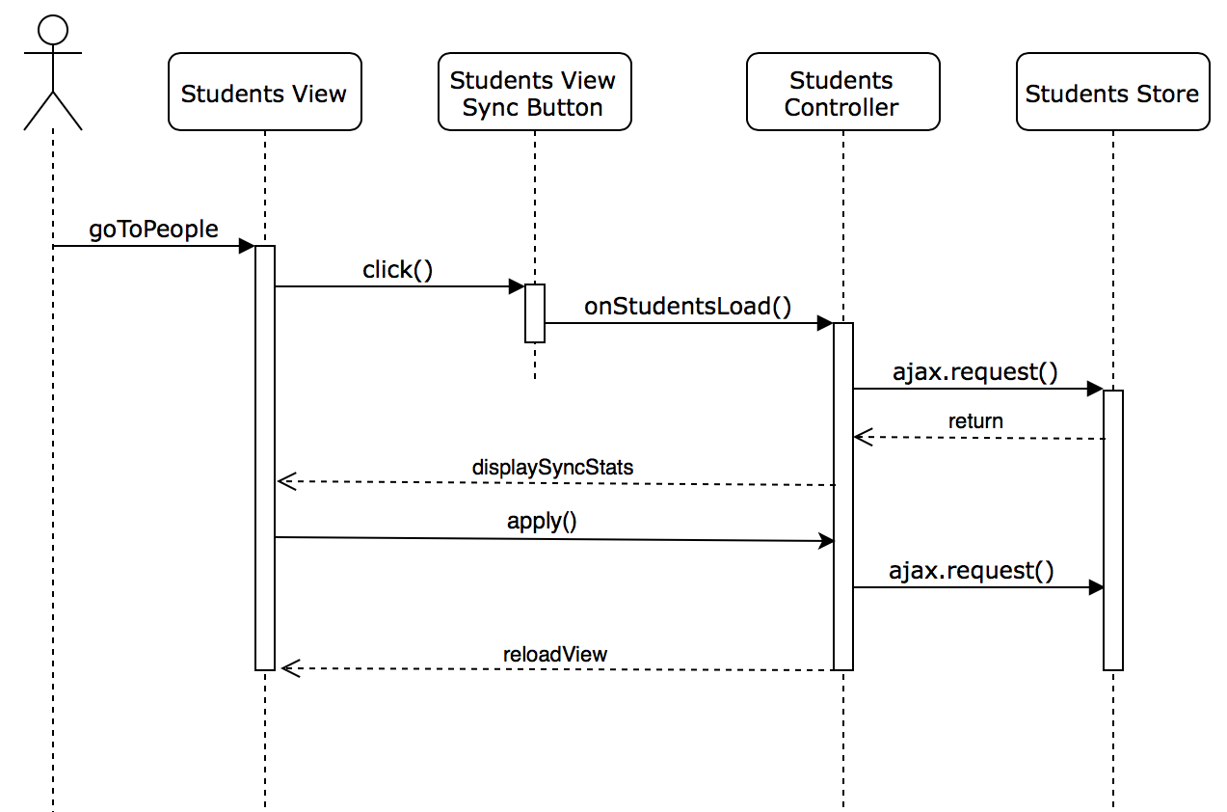

Student Sync Sequence Diagram

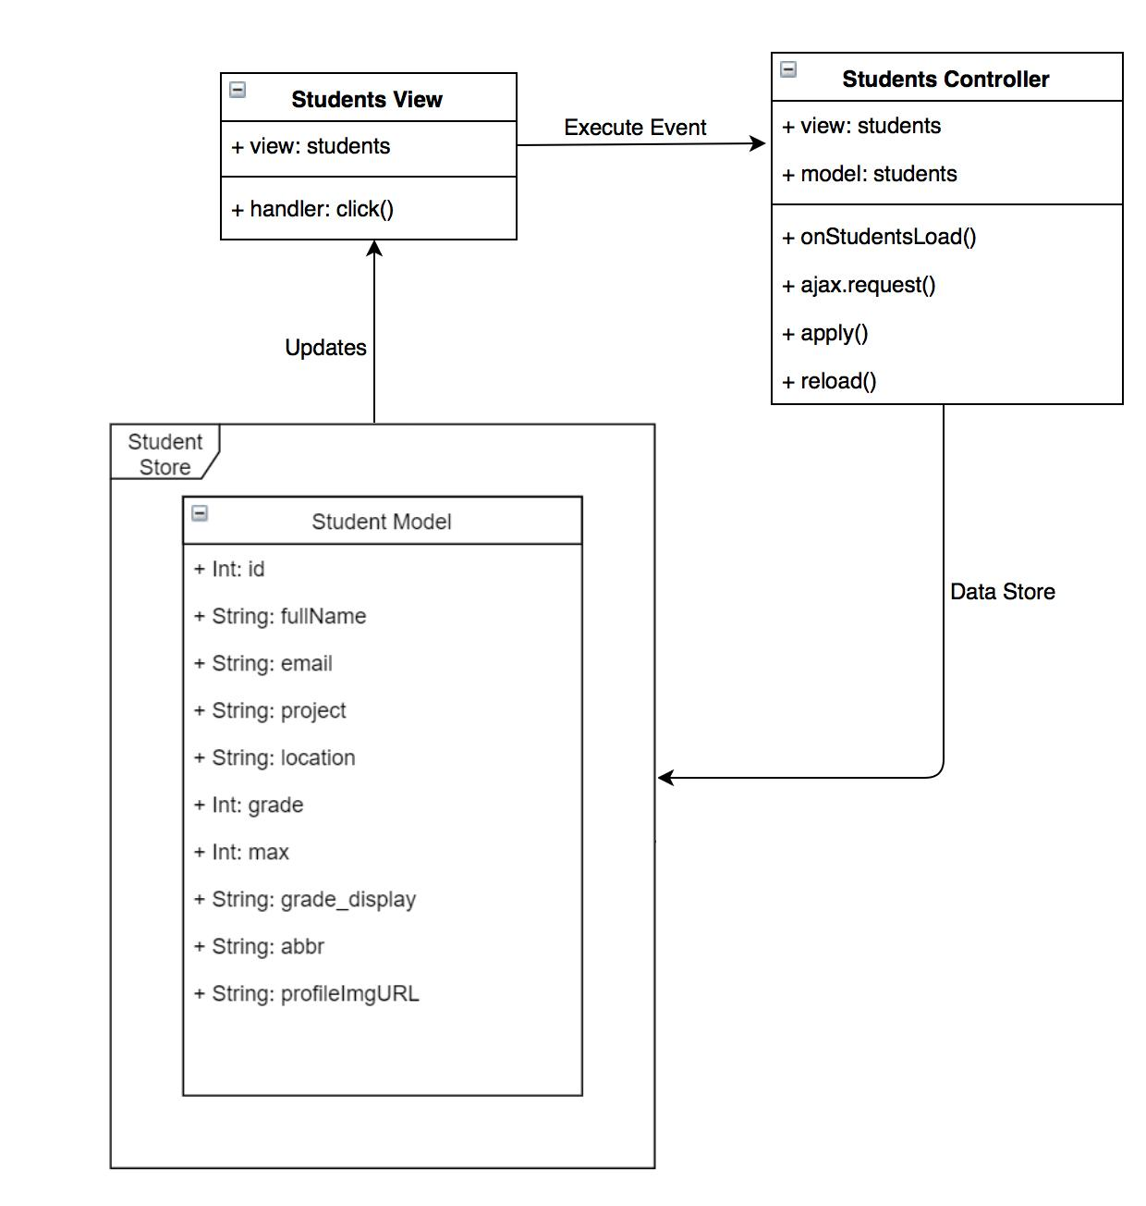

Student Sync Class Diagram

## 

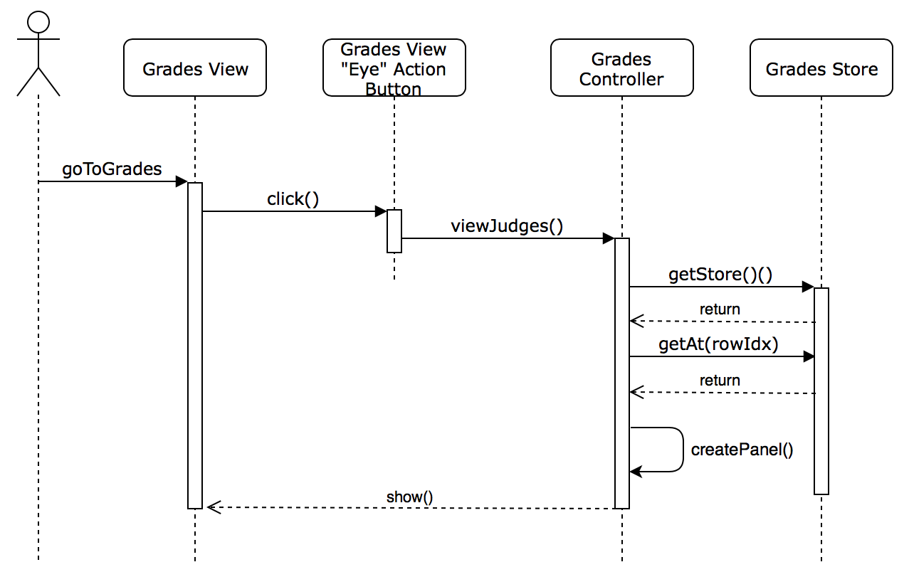

Students Grade View Sequence Diagram

## 

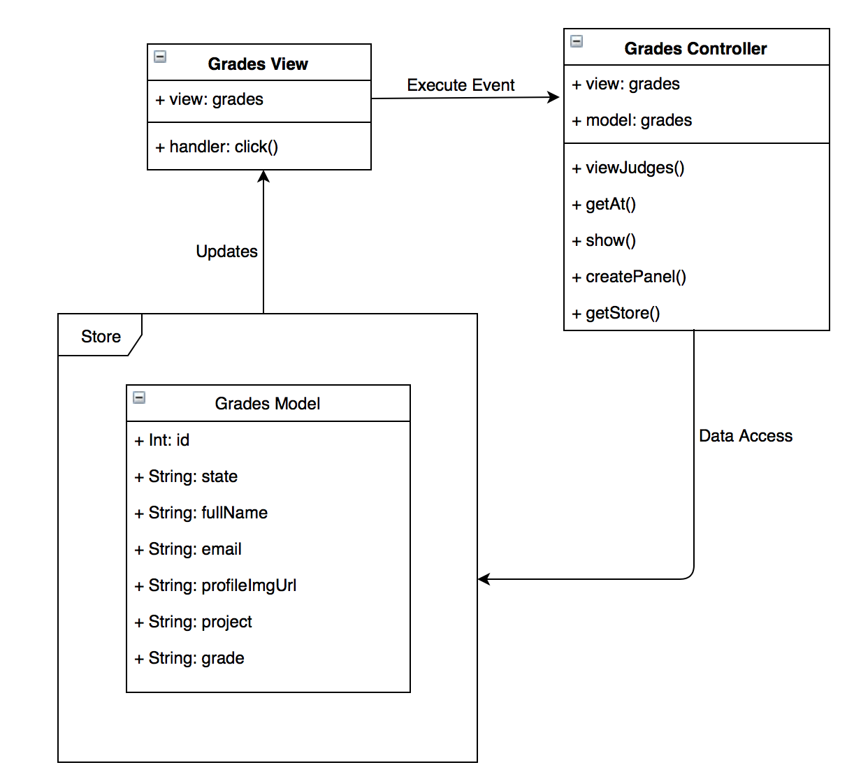

Students Grade View Class Diagram

## 

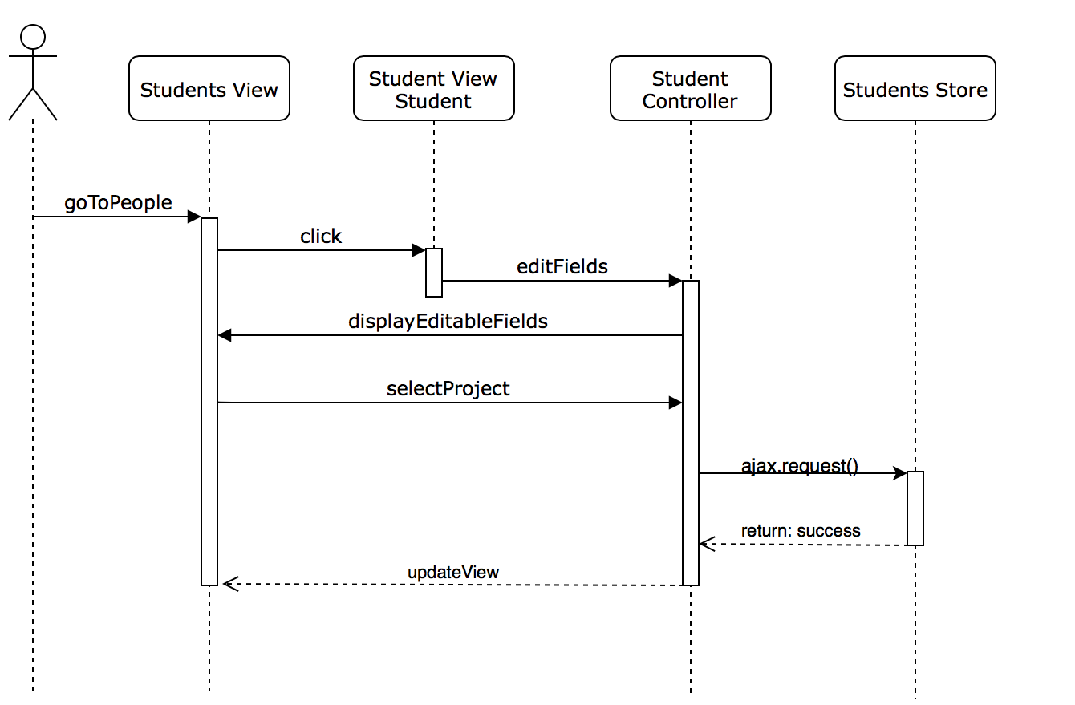

Students Project ComboBox Sequence Diagram

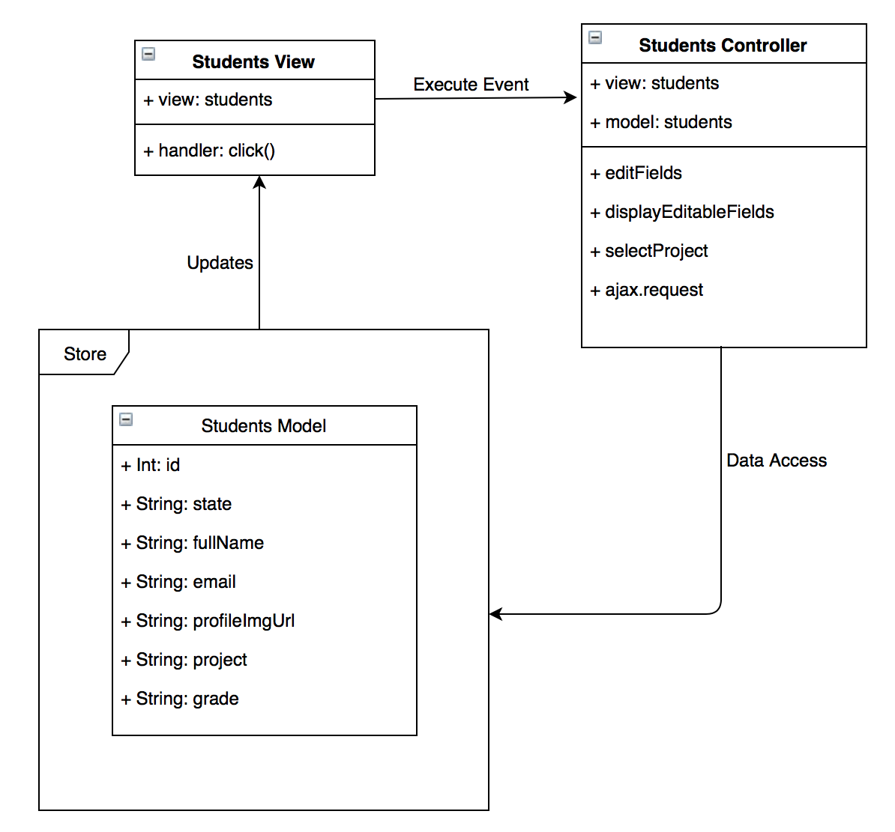

Students Project ComboBox Class Diagram

## 

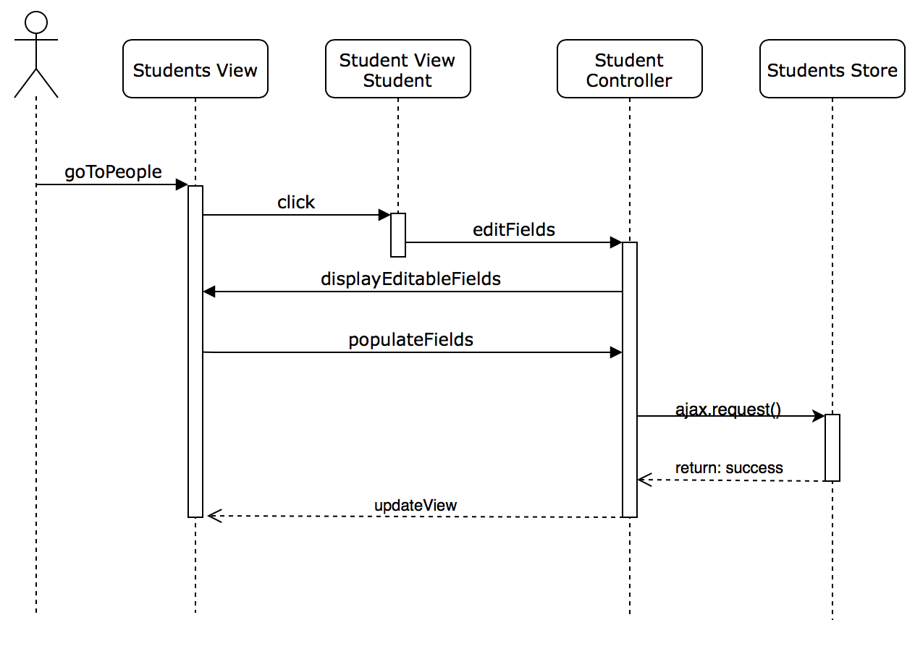

Students Location Field Edit Sequence Diagram

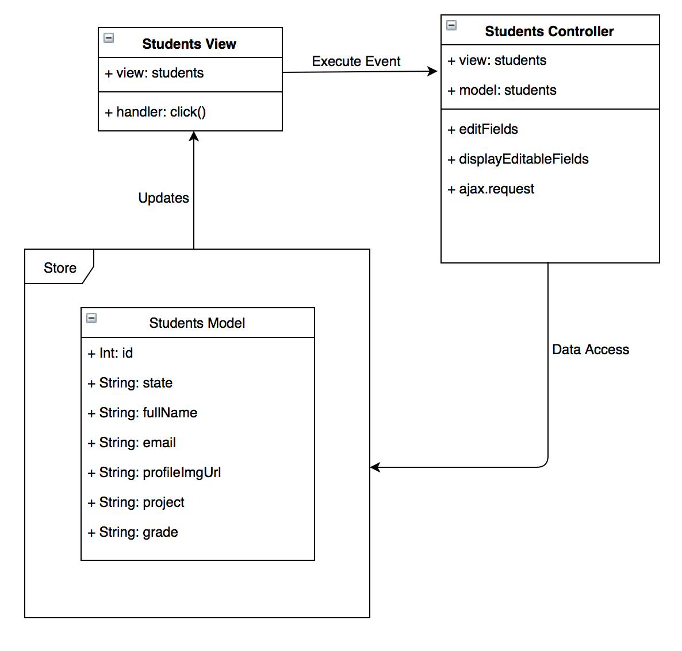

Students Location Field Edit Class Diagram

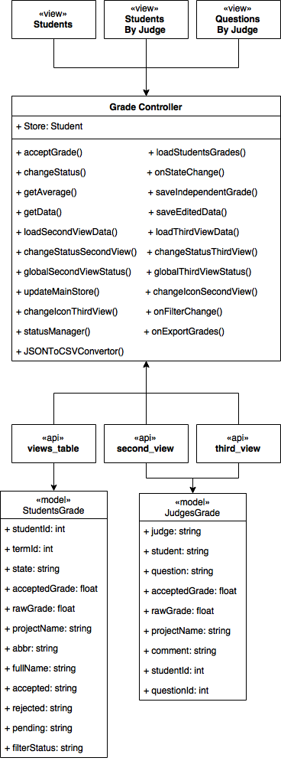Grades - Class Diagram

## Appendix B - User Interface Design

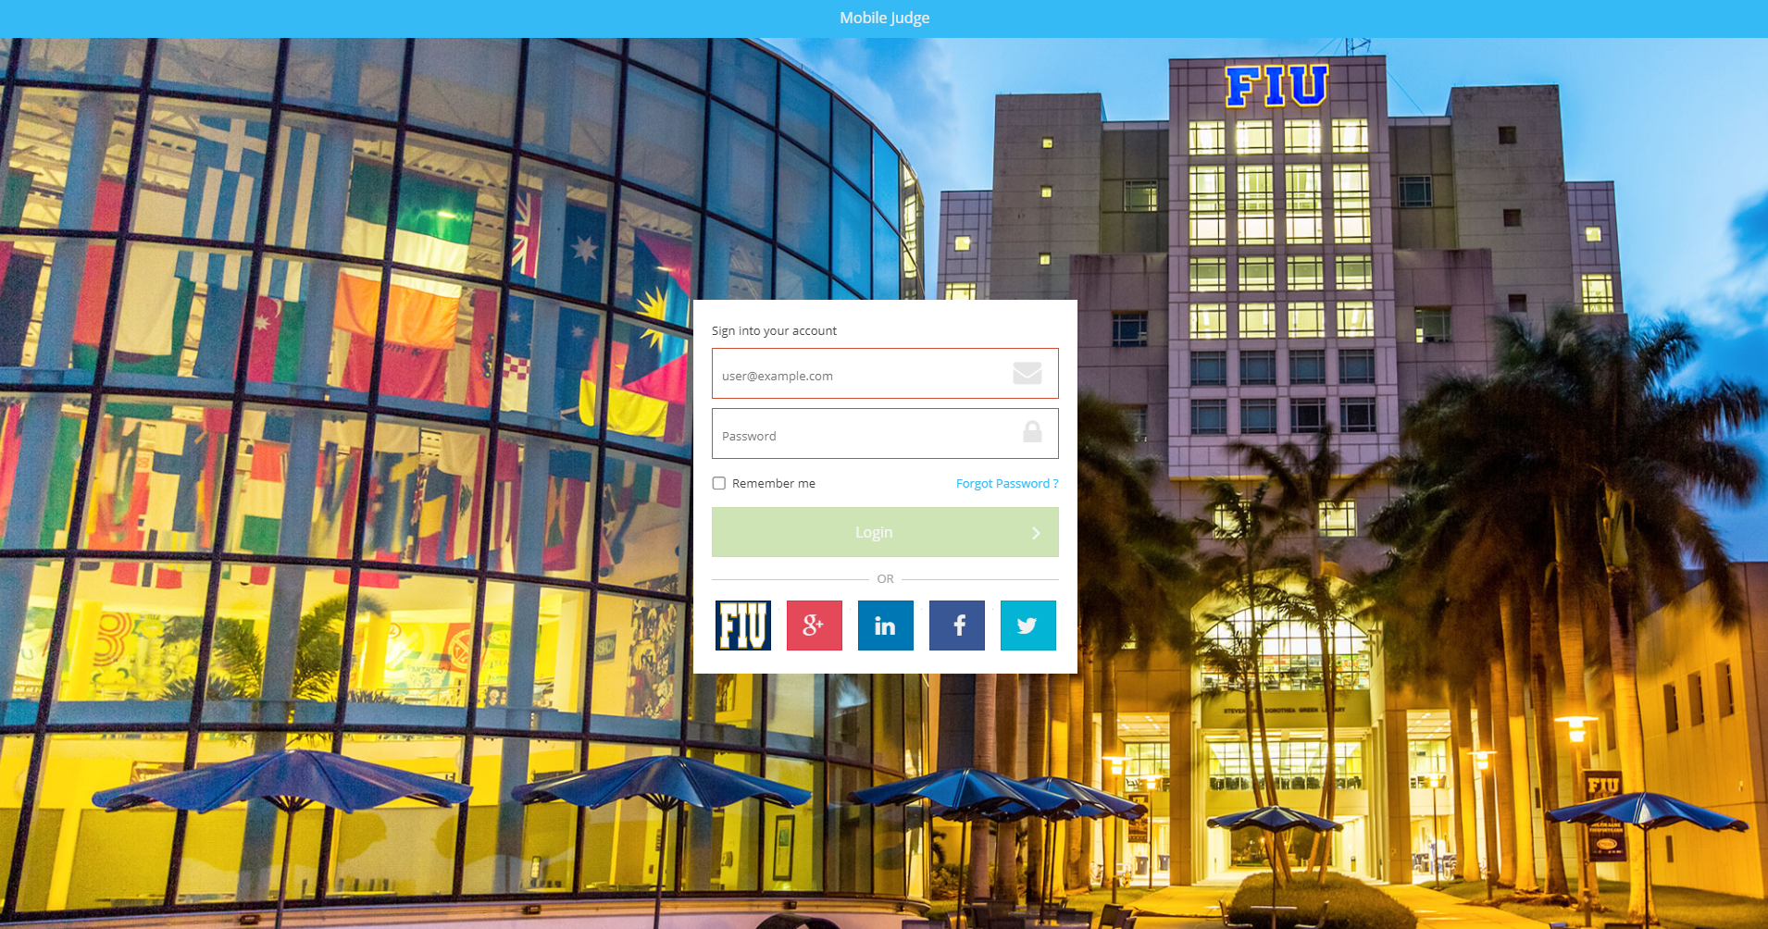

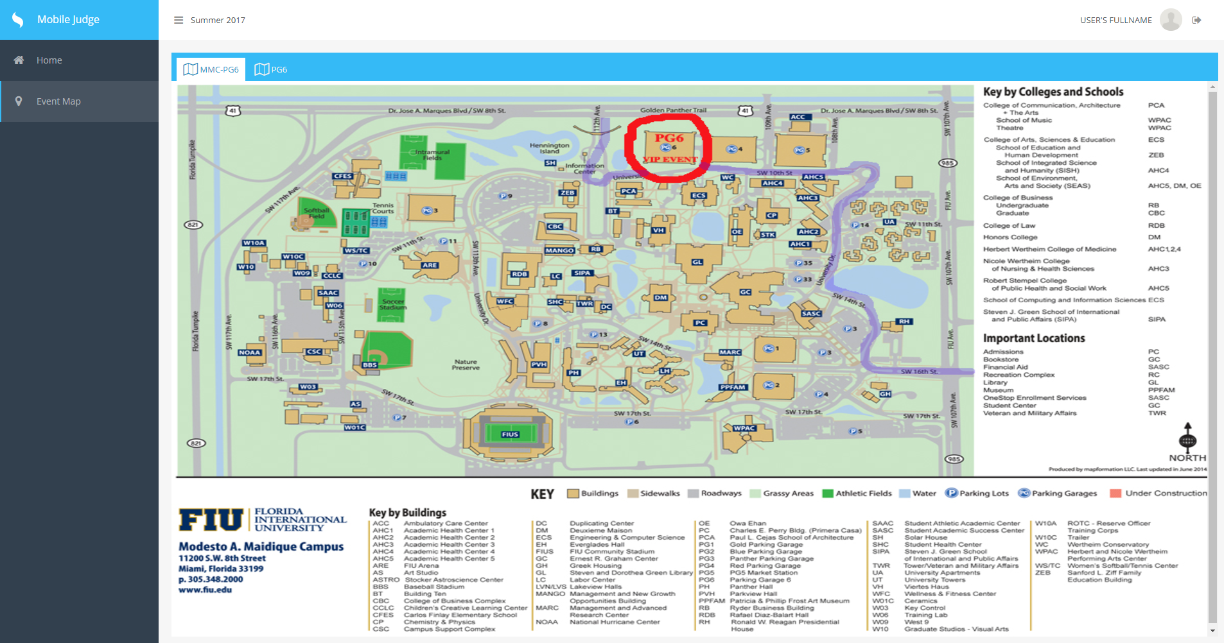

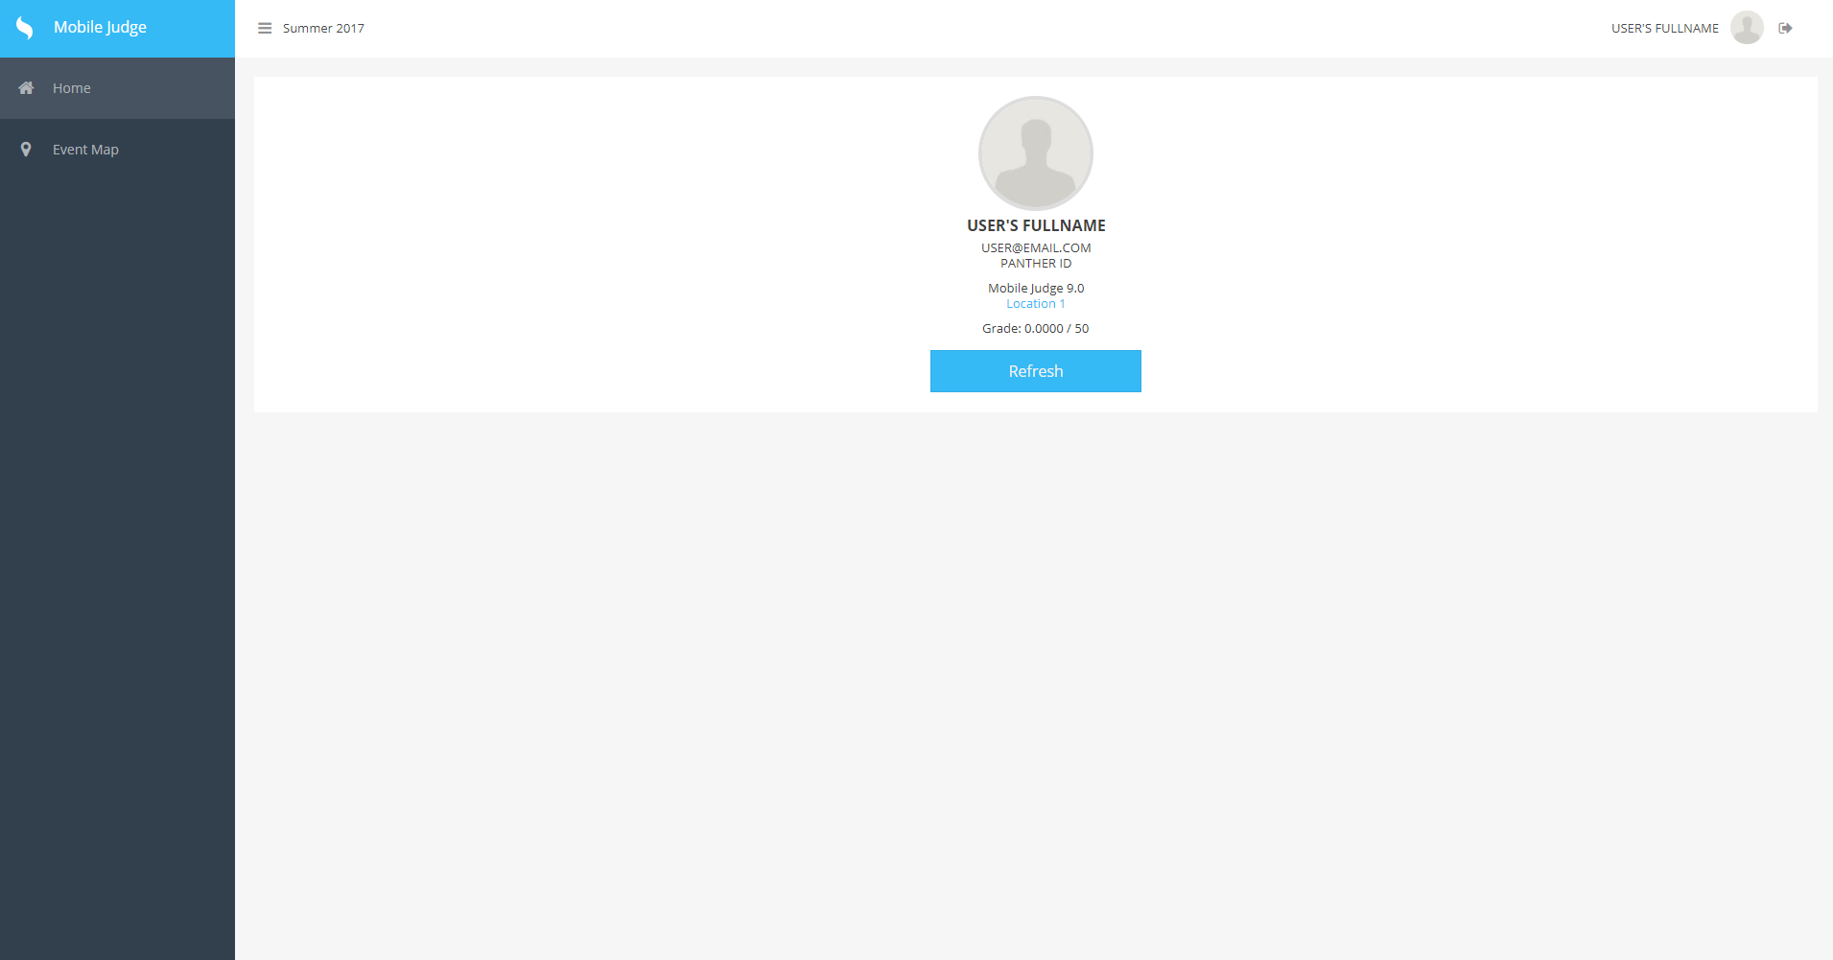

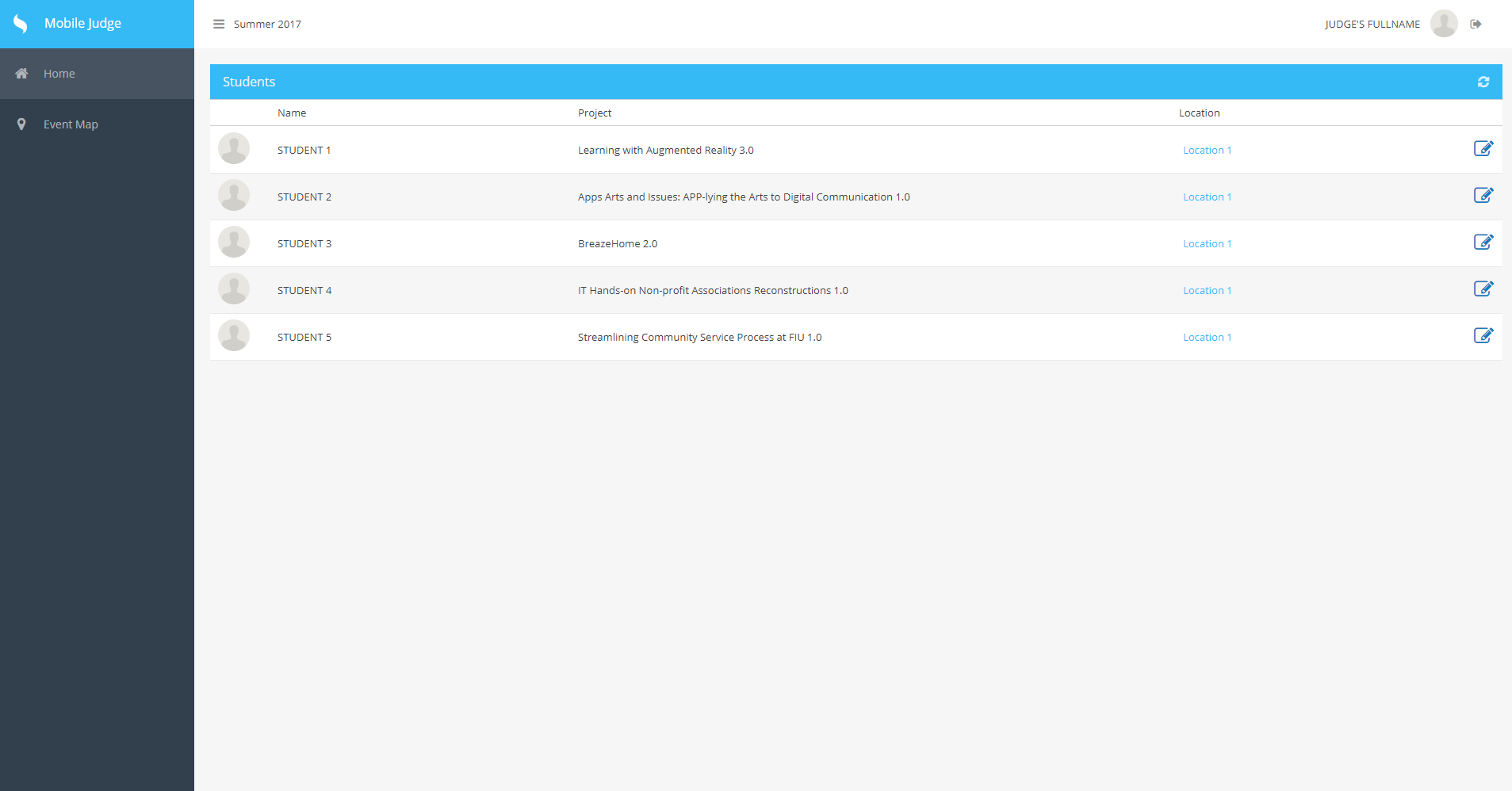

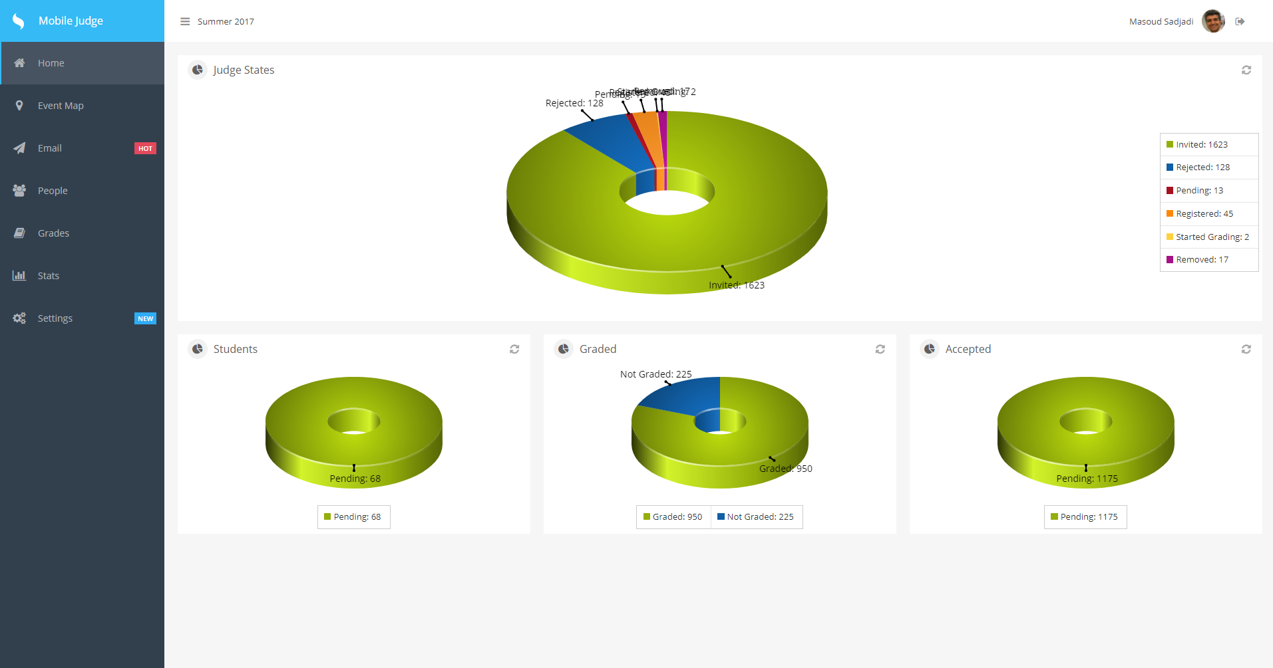

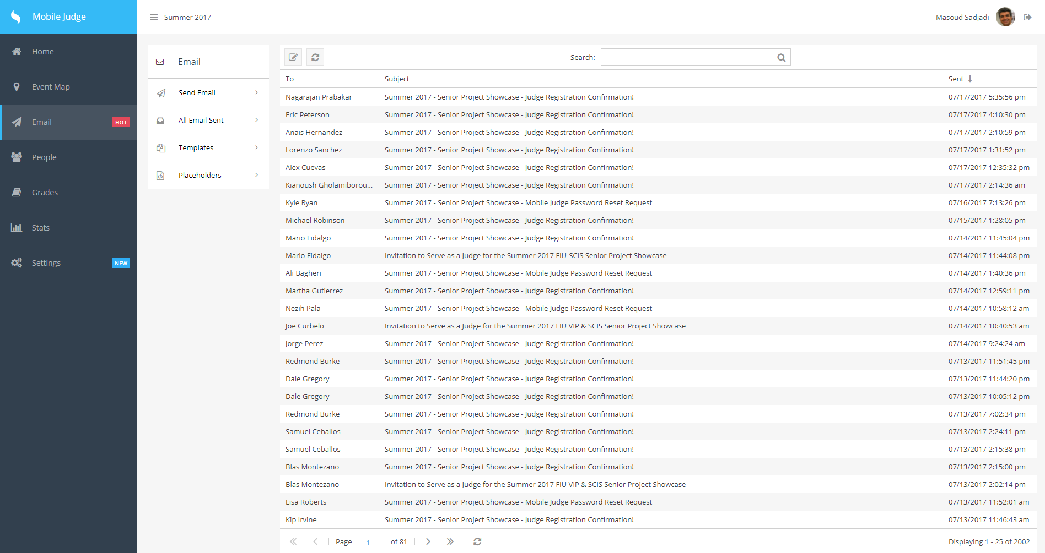

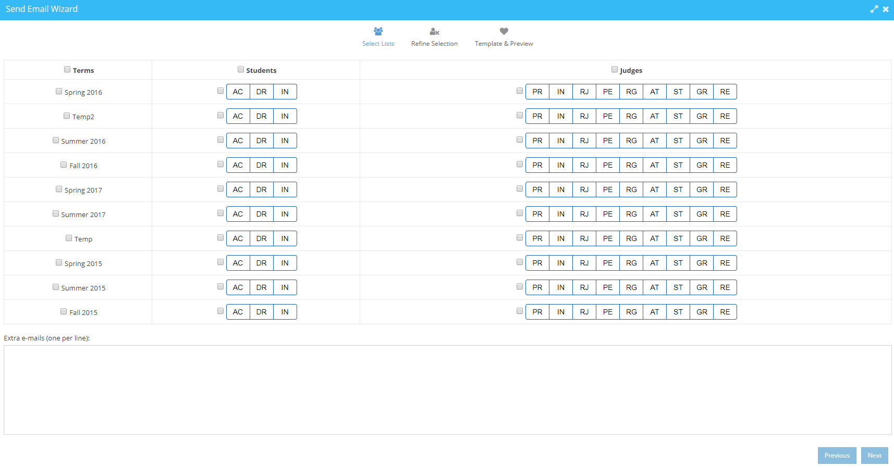

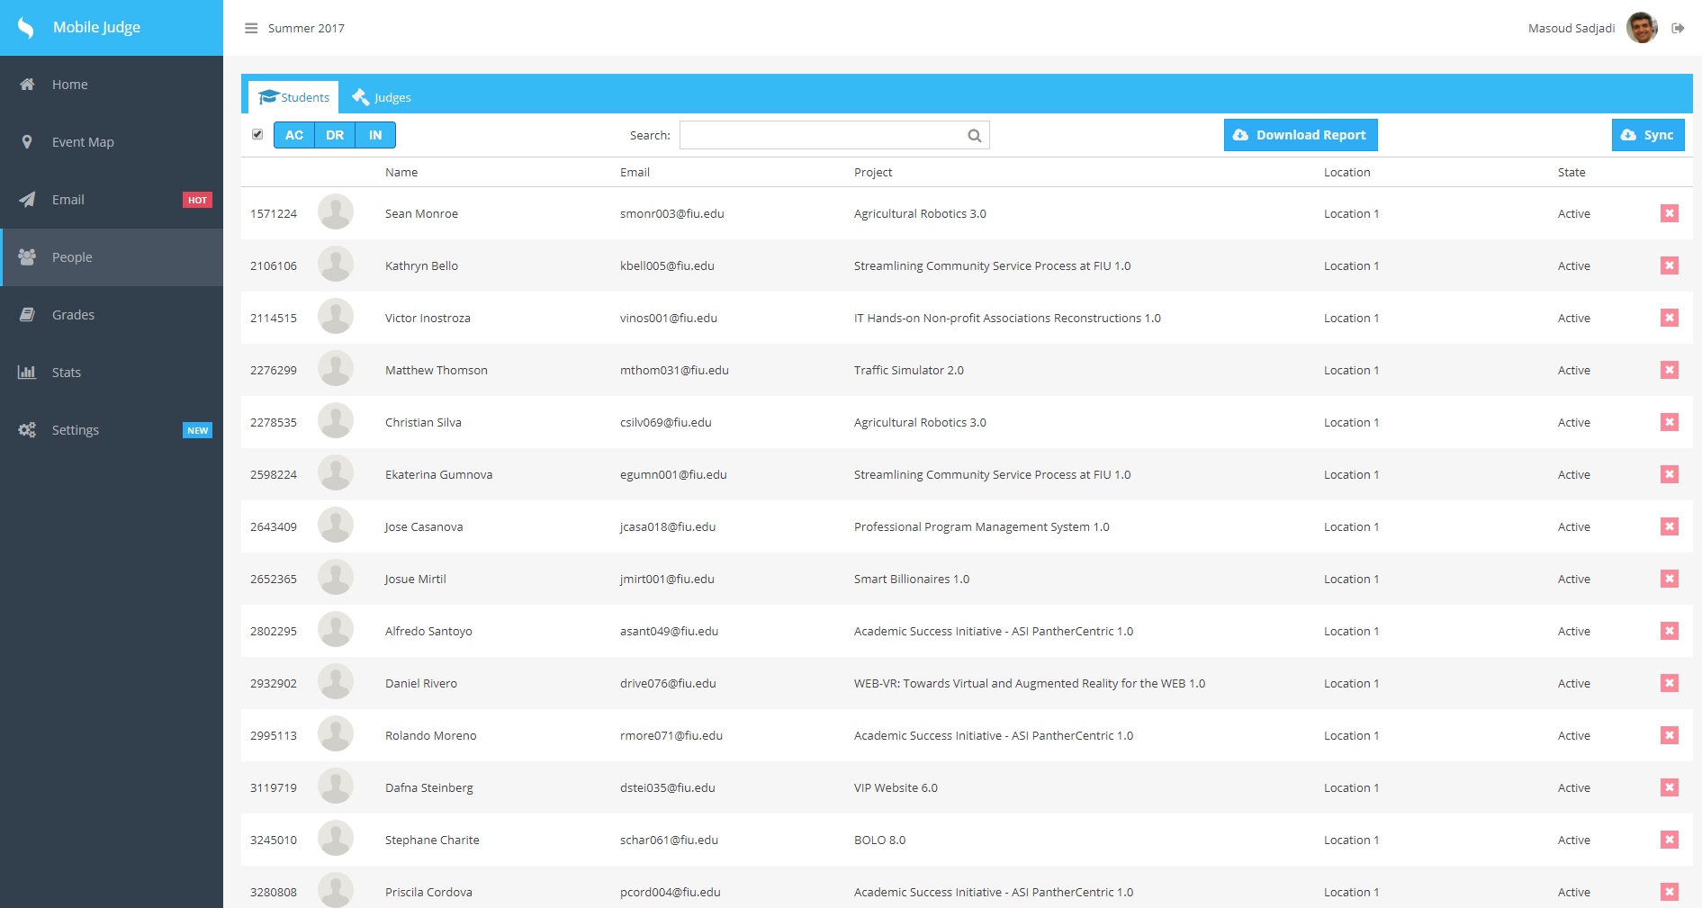

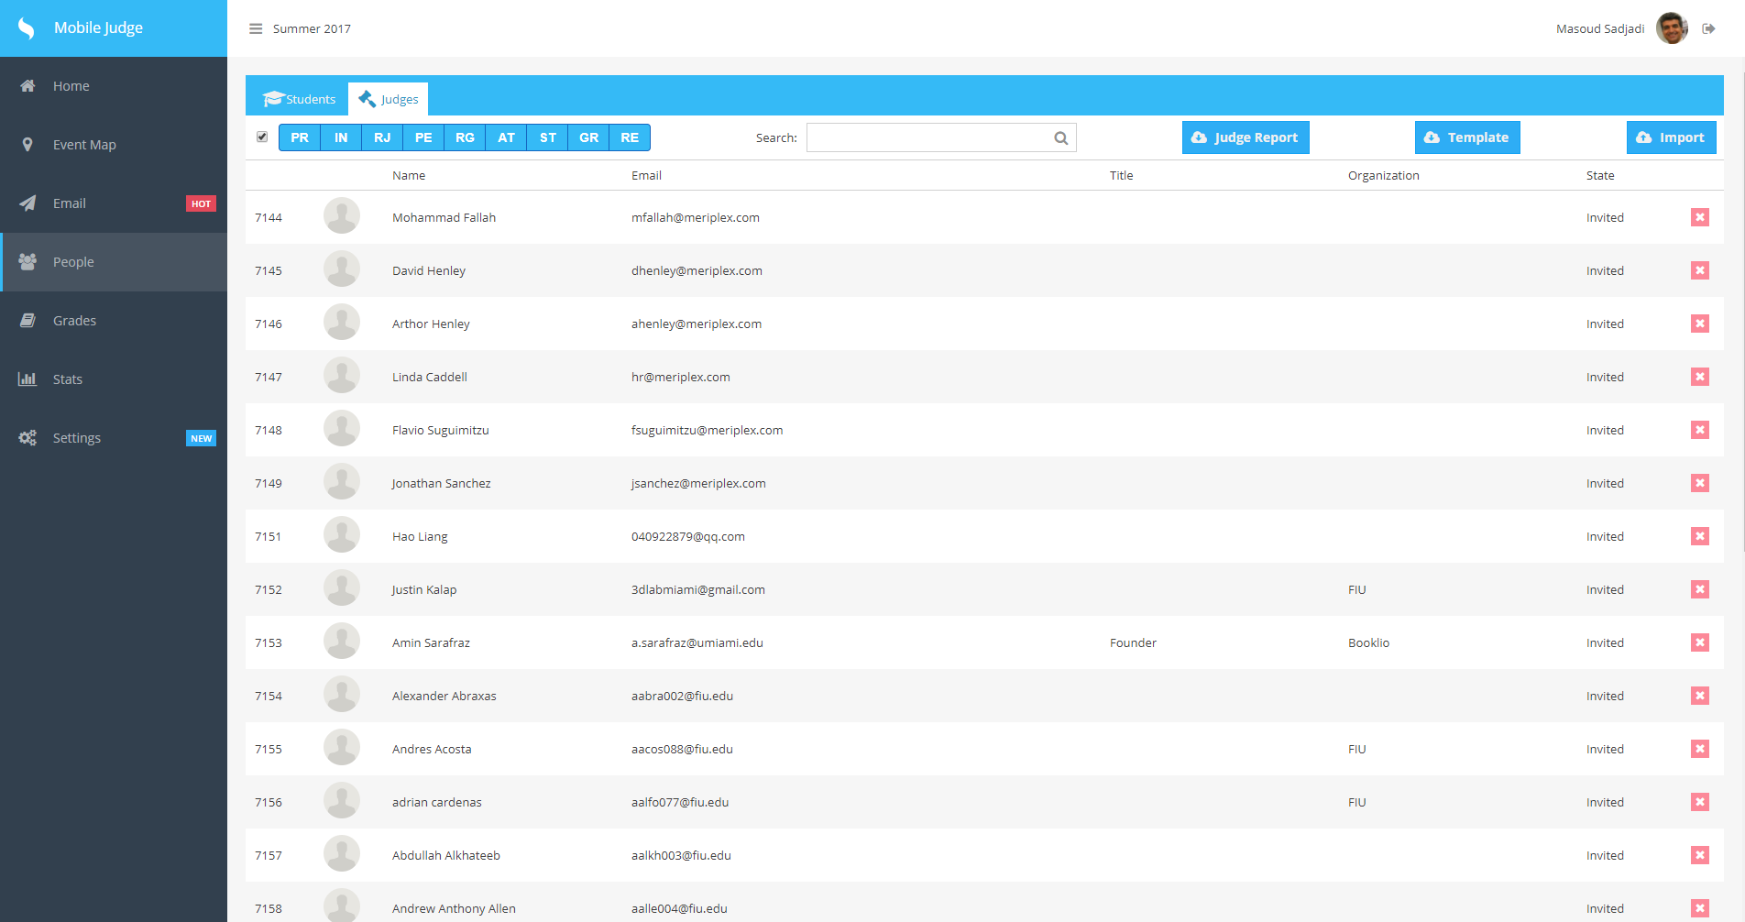

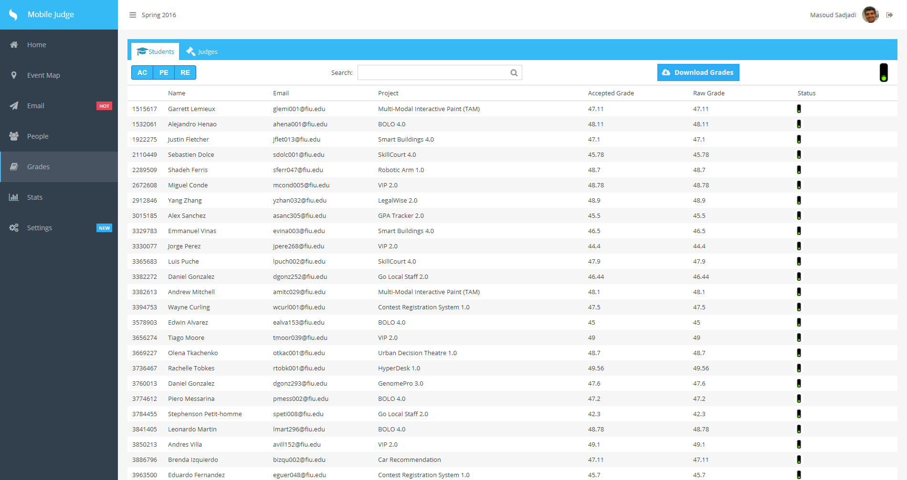

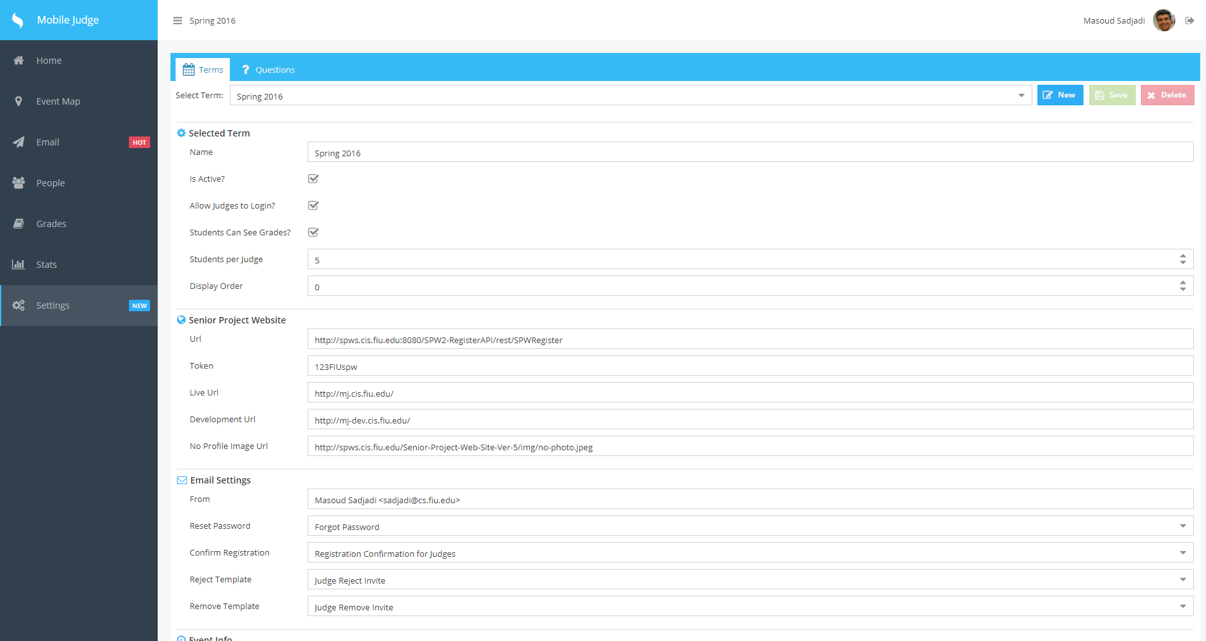

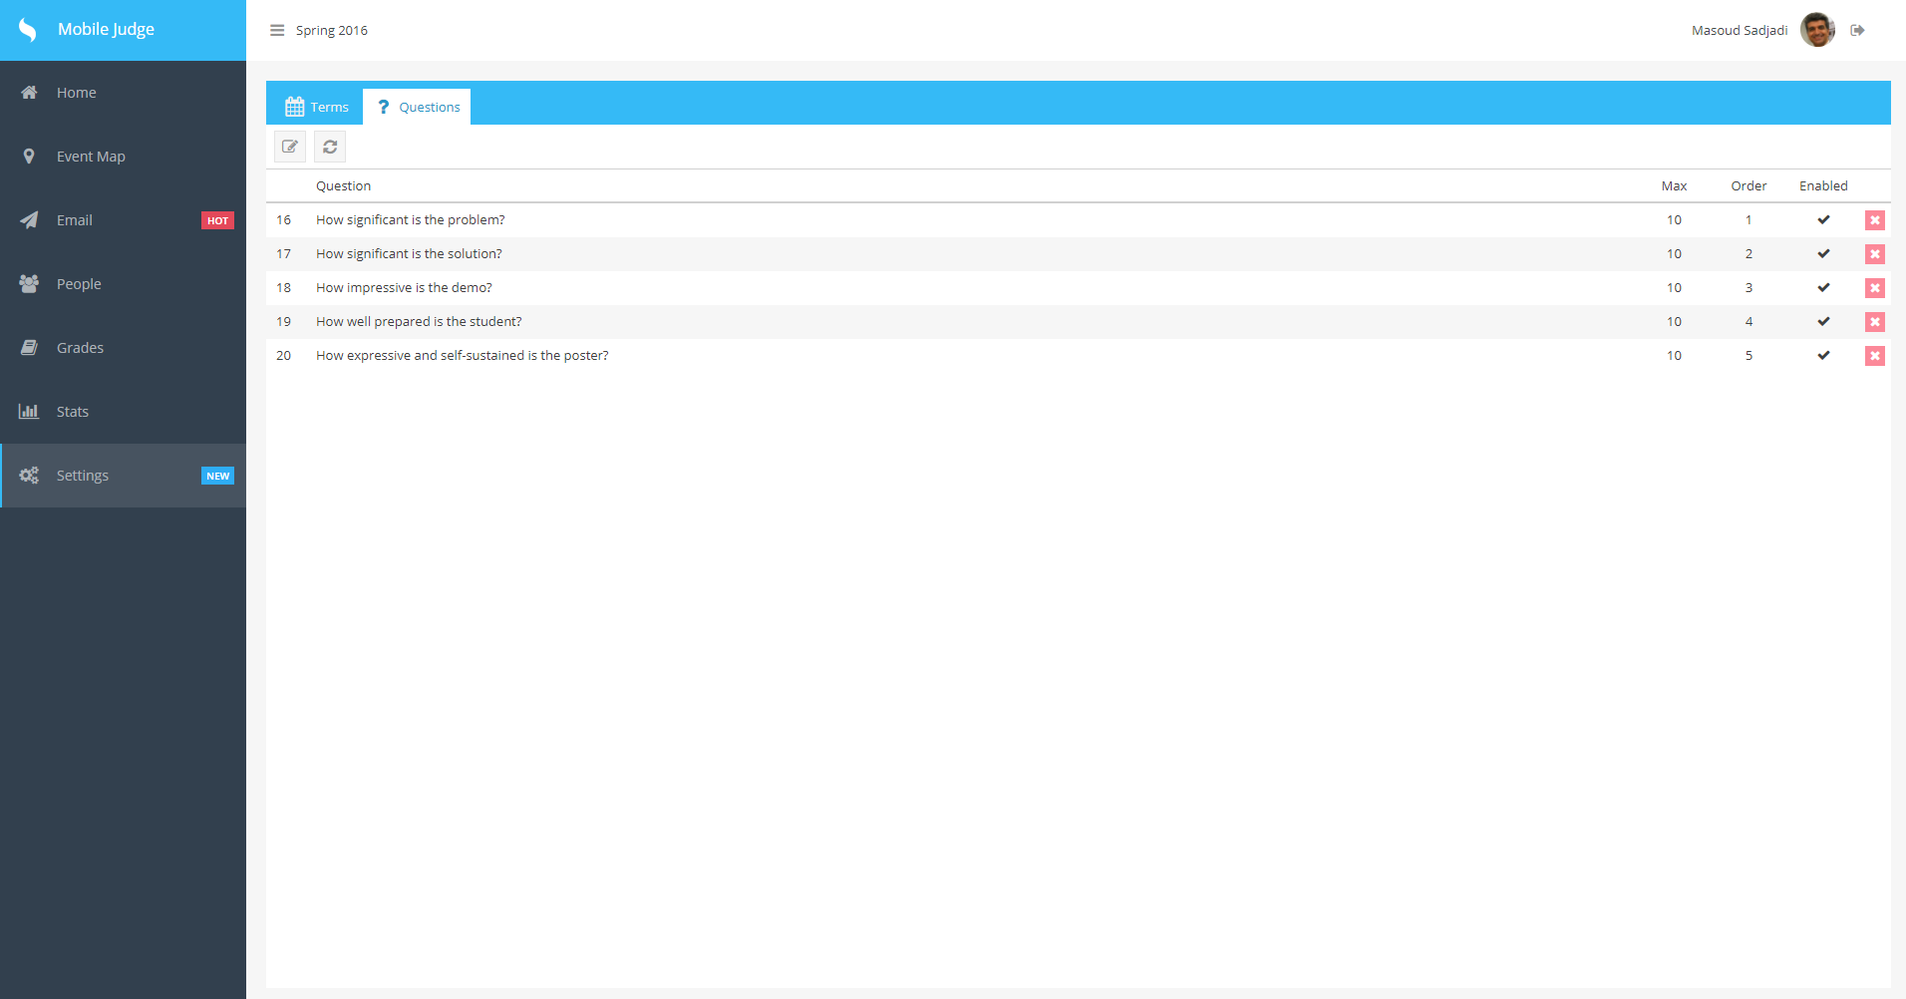

## Appendix C - Sprint Review Reports

**Sprint Review Meeting Minutes**

**Release 9, Sprint 1**

Attendees: Masoud, Mario Fidalgo, Kyle Ryan

Start time: 3:10 pm, May 30, 2017

End time: 3:13 pm, May 30, 2017

After a show and tell presentation, the implementation of the following user stories were accepted by the product owners: All.

* Mario & Kyle
* User Story #642 Learn Sencha 2.0
* User Story #643 Read documentation from Version 5 & 6
* User Story #644 Review videos of MobileJudge
* User Story #645 Experiment current MobileJudge website
* User Story #646 Access the VM of MobileJudge

**Sprint Review Meeting Minutes**

**Release 9, Sprint 2**

Attendees: Masoud, Mario Fidalgo, Kyle Ryan

Start time: 4:10 pm, June 12, 2017

End time: 4:13 pm, June 12, 2017

After a show and tell presentation, the implementation of the following user stories were accepted by the product owners: All.

* Mario Fidalgo

#647 - Allow student fields to be edited

#648 - Allow Judge fields to be edited

#649 - Download/Export Accepted Grades

* Kyle Ryan

#651 - Add new filter button to Students

#652 - Add new filter button to Judges

#653 - Add downloadable template for Judges

#654 - Modify Import function

**Sprint Review Meeting Minutes**

**Release 9, Sprint 3**

Attendees: Masoud, Mario Fidalgo, Kyle Ryan

Start time: 1:10 pm, June 26, 2017

End time: 1:13 pm, June 26, 2017

After a show and tell presentation, the implementation of the following user stories were accepted by the product owners: All.

* Mario Fidalgo

#650 - Bug: Fix issue with Sync

#655 - Add grades tab

#658 - Add Combobox for Projects in Students

#659 - Bug: Fix issue with Location edit

* Kyle Ryan

#660 - Deploy changes to MJ-Dev

#661 - Modify Judges Registration Form Descriptions

#662 - Add visual cue for filter buttons

**Sprint Review Meeting Minutes**

**Release 9, Sprint 4**

Attendees: Masoud, Mario Fidalgo, Kyle Ryan

Start time: 1:11 pm, July 10, 2017

End time: 1:14 pm, July 10, 2017

After a show and tell presentation, the implementation of the following user stories were accepted by the product owners: All.

* Mario Fidalgo

#656 - Add approve and reject buttons

#666 - Add a question view for each Judge

#665 - Add a Judges view for each student

* Kyle Ryan

#663 - Add combobox in students/judges tab for status

#664 - Add Students View to Grades

#667 - Expand descriptions for Registration Form

#668 - Deploy changes to mj-dev

## Appendix D - User Manuals, Installation/Maintenance Document, Shortcomings/Wishlist Document and other documents

**Shortcomings/Wishlist**

There were a few items that were not completed:

* Adding stats live view
* Adding judges list to grades section (Second View)
* Adding students to each judge on that list (Third View)
* Make the Grades and People tabs mobile compatible

The judges list in the grades section was coded but has yet to be deployed.

For the upcoming version of Mobile Judge, a few things that could be interesting to develop and implement are:

* Live Statistics during the Showcase
* Make everything compatible with mobile devices
* Allow administrator to change the role of users to admin, judge, or student
* Sync with VIP website

**Installation & Maintenance Document**

<https://www.sencha.com/products/extjs/#overview>

Documentation: <http://docs.sencha.com/extjs/6.0/>

Please follow the getting started guide: <http://docs.sencha.com/extjs/6.0/getting_started/getting_started.html>

But if you want to get a deep crash course of the framework follow this one instead:

<http://docs.sencha.com/extjs/6.0/getting_started/login_app.html>

Then I suggest head to the examples page and get familiar with the UI components (chances are you are going to end up adapting some of these to your own)

<http://examples.sencha.com/extjs/6.0.1/examples/>

**Note:** Don’t download the commercial version as indicated by the guides. Grab the GPL version from here instead: <https://www.sencha.com/legal/GPL/>

If the IDE of choice is WebStorm (which you can get a free student license from here <https://www.jetbrains.com/student/>) I suggest you install the ExtJS library since it can help in the inspection and autocompletion. If the option is not present click the Download button to the right.

**This guide is to setup our web server (NGINX) to serve as a front for static content (sencha files) and reverse proxy for nodejs (api / backend) and oauthd (oauth authentication). This will also host phpmyadmin to help on the db operations.**

1. **MariaDB 10.1**  
     
   To install MariaDB please go here <https://downloads.mariadb.org/mariadb/repositories/> and select the closest mirror and the appropriate binaries for your distribution. In my case I selected Ubuntu 14.04 “Trusty” and DigitalOcean NY as the mirror.  
     
   $ sudo apt-get install software-properties-common  
   $ sudo apt-key adv --recv-keys --keyserver hkp://keyserver.ubuntu.com:80 0xcbcb082a1bb943db  
   $ sudo add-apt-repository 'deb [arch=amd64,i386] http://nyc2.mirrors.digitalocean.com/mariadb/repo/10.1/ubuntu trusty main'  
     
   At this point follow the installation as you would with a mysql setup.  
   $ sudo apt-get update  
   $ sudo apt-get install mariadb-server  
   $ sudo mysql_secure_installation
2. **PhpMyAdmin**  
     
   $ sudo apt-get install php5-fpm php5-mysql php5-mcrypt  
     
   $ sudo vi /etc/php5/fpm/php.ini  
   Find the line with “;cgi.fix_pathinfo=1” replace it with “cgi.fix_pathinfo=0”  
     
   $ sudo php5enmod mcrypt  
   $ sudo service php5-fpm restart  
     
   $ sudo apt-get install phpmyadmin  
     
   Do not check any of the web servers as nginx is not part of the list.   
   Check yes to “Configure database for phpmyadmin with dbconfig-common?”  
   It will also ask for the root password that you specified above and set a new one for the phpmyadmin user (it can be the same one but for security it should be different)
3. **NGINX**  
     
   $ sudo apt-get install nginx  
     
   Add some fonts mime types to nginx:  
     
   $ sudo vi /etc/nginx/mime.types  
     
   font/ttf ttf;  
   font/opentype otf;  
   application/font-woff woff;  
   application/vnd.ms-fontobject eot;  
     
   Add “client_max_body_size 5M;” before the include of mime types:  
   $ sudo vi /etc/nginx/nginx.conf  
     
   Setup the site configuration as the one I’ve uploaded to this folder:  
   $ sudo vi /etc/nginx/sites-enabled/default  
     
   Symlink phpmyadmin into your nginx root directory  
   $ sudo ln -s /usr/share/phpmyadmin /usr/share/nginx/html  
     
   Apache may still be running. Check with this command  
   $ service --status-all  
     
   Stop apache2 if running  
   $ sudo service apache2 stop  
     
   Restart and browse to http://yourserverip/ and <http://yourserverip/phpmyadmin/>  
   $ sudo service nginx restart

**OAuthd admin**To be able to access the oauthd instance just remove or rename the config.local.js from the oauthd folder. This will reset all the bindings to listen to all ip address instead of just localhost. After working with the admin, restore the config.local.js to its original so the admin is not accessible from outside.

You can access the admin site at c

username: [sadjadi@cs.fiu.edu](mailto:sadjadi@cs.fiu.edu)

password: Judge2015

We are using the following keys:

|  |  |  |  |  |
| --- | --- | --- | --- | --- |
| **Provider** | **ClientId** | **Secret** | **Scope** | **Extra** |
| LinkedIn2 | 77f7r4zh0rdc5s | TcWFVKGW3OnP0lDz | r_basicprofile, r_emailaddress |  |
| Twitter | IxufoHxASt5wkzLr9MpMJw754 | SYi8X9t8x0bHRCbOy9xhATwvoznKfIJ5Jry4Y5n1roAz2gDx95 |  |  |
| Facebook | 1657227221222913 | 97979fb246a2c3fbb7444dfbb6b151b4 | email, user_about_me | api_version: v2.3 |
| Google | 153038497251-idf2tmj  3hljvdppk5g5tr6jb849q91st.apps.googleusercontent.com | MiEkCeUXVF6Lza9Gdkp_D-A_ | openid, email, https://www.googleapis.com/auth/userinfo.profile | access_type: online |
| FIU | same as above | | | domain: fiu.edu |

The site will look like this:

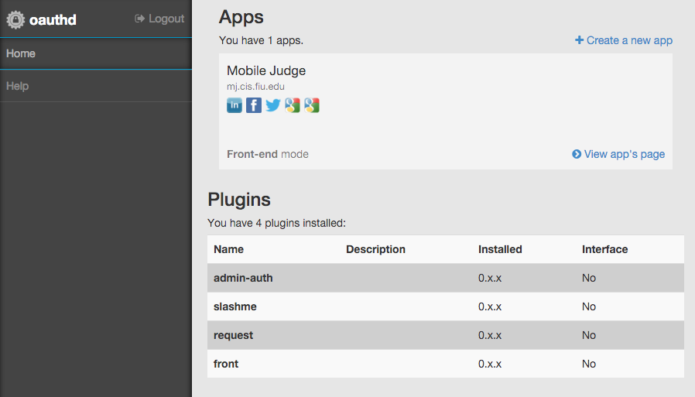

**This guide is to show how to build the sencha app and deploy it to site along with the nodejs backend.**

1. **Sencha Cmd**$ wget <http://cdn.sencha.com/cmd/6.0.2/no-jre/SenchaCmd-6.0.2-linux-amd64.sh.zip>  
   $ unzip SenchaCmd-6.0.2-linux-amd64.sh.zip  
   $ sudo apt-get install default-jre  
   $ ./SenchaCmd-6.0.2.14-linux-amd64.sh  
   $ sencha  
   Sencha Cmd v6.0.2.14  
   …  
   (If the sencha command does not work, run ‘source .bash_profile’)  
     
   Quick overview of Sencha Cmd can be found here: <https://www.sencha.com/blog/sencha-cmd-enterprise-workflow/>
2. **Build production version**If you followed the [getting started guide](http://docs.sencha.com/extjs/6.0/getting_started/getting_started.html) for the Sencha Framework you should have a folder structure with everything in place. Next you can grab the code from the git repo and overwrite everything there and do  
      
    $ sencha app refresh  
    $ sencha app build production  
     
   The minified version of your app with all the styles and toolkits compiled is under the build/production folder. One hint of advice right after building a production version execute the following to reset back your workspace to a development mode.  
     
    $ sencha app build development
3. **Deploy  
   (**the api folder (is the output) will be named server in the MobileJudge directory, and copy over client/build/production/\***)**Deployment is very easy:   
   - Copy the output from the sencha cmd above under the root of your nginx server (usually /usr/share/nginx/html).  
   - Copy the api folder to the same folder as above and execute “npm install” (if you include the node_modules folder then no need for last).  
   - Deploy the database either using phpmyadmin or the mysql cli tool.  
   - Update the api/config/database.json file accordingly. prt   
   - Start the backends with either one of these options (first 2 are for dev/test)  
    $ node index.js  
    $ nodemon index.js  
    $ pm2 start index.js --watch
4. **Node Process Management & Server Monitoring (PM2)**Create an account at <https://app.keymetrics.io> This will allow us to monitor the health of the server remotely and inspect what’s is happening with out backend. It will also allow to keep the node applications running and restart them in the event of a server failure or any file is updated (handy for deploy).Documentation and quick start reference: <http://docs.keymetrics.io/> <http://pm2.keymetrics.io/docs/usage/quick-start/>   
   **Note**: the keys provided here are for the VIP Senior Project bucket. I will send invitations to all of you so you guys can join it.  
   $ wget -qO- http://install.keymetrics.io/install.sh | SECRET_ID=c4oqalvhmicddmz PUBLIC_ID=7wu2tbb2eyc6sh1 sudo bash  
   $ sudo pm2 link c4oqalvhmicddmz 7wu2tbb2eyc6sh1 mj.cis.fiu.edu  
   $ sudo pm2 install pm2-server-monit  
   $ sudo pm2 install pm2-mysql  
   $ sudo pm2 install pm2-redis  
   $ sudo pm2 set pm2:passwd Judge2016  
     
   $ cd /usr/share/nginx/html/api  
   $ sudo pm2 start index.js -i 0 --watch --name "mj-api"  
   $ cd /usr/share/nginx/html/oauthd  
   $ sudo pm2 start index.js -i 0 --watch --name "mj-oauthd"  
     
   $ sudo pm2 save  
   $ sudo pm2 startup ubuntu
5. **Smtp Relay Setup  
     
   Live**$ sudo apt-get install sendmail  
   $ sudo sendmailconfig  
     
   $ sudo vi /etc/mail/sendmail.mc  
   Add   
    define(`SMART_HOST', `mail.cs.fiu.edu')dnl  
   before  
    MAILER_DEFINITIONS  
     
   $ sudo /etc/init.d/sendmail restart  
    **Test/Dev**For development and testing pusposes in order to test the email functionality but no sending emails out you can either fake the smtp host above with your own smtp server or use a redirect/captcha like explained here <http://distinctplace.com/2013/06/20/nullmailer-and-fake-mail---two-little-tools-for-every-developer/>

# References

Mobile Judge 8: [LINK](https://github.com/FIU-SCIS-Senior-Projects/MobileJudge8)

Mobile Judge 7: Frank Hernandez: [LINK](https://drive.google.com/open?id=0B457zg45quzrZjl5Nm5GUW81b0k)